**AP US History Review**

**Writing Practice Prompts**

**Unit 1**

**Instructions**

1. **You should read the 5 steps to a 5 book summary for Unit 1: 1492-1607 before completing the prompts below**
2. **For each prompt complete the following tasks**

* **Provide a Thesis statement**
* **Connect one HAPPY/HIPP point from the document to your thesis statement**
* **Provide 1 specific piece of information not connected to the document and explain how the evidence connects to your thesis statement**

**Prompt 1**: Explain how and why various native populations in the period before European contact interacted with the natural environment in North America.

**Document for Prompt 1**

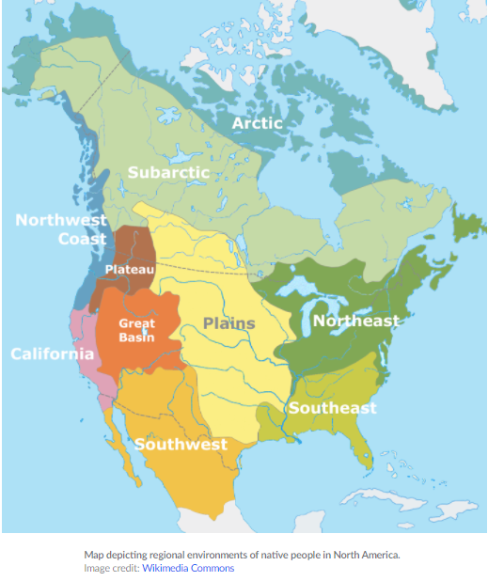

**Prompt 2:** Explain the causes of exploration and conquest of the New World by various European nations

**Document for Prompt 2**

### **The Changing Order**

The Renaissance was an age of paradox in Europe. This period witnessed dramatic changes in cultural and intellectual life, linked to the enthusiastic rediscovery of the ancient Greek and Roman past. Artists and writers brought a new, intense scrutiny to the individual human subject within the context of an emerging secular spirit. Yet, during the Renaissance, religious mysticism, superstition, and political authoritarianism intensified.

Though handwritten and illuminated manuscripts had been the preserve of the learned few, the invention of printing led to a democratization of information. The creation of increasingly modern and powerful economies, based on banking, trade, and commerce enabled an emerging middle class to participate in this free exchange of ideas. Readers were exposed to dramatically different world views, ranging from imaginary maps and travel accounts to information partly based on practical experience.

**Prompt 3:** Explain the effects of the Columbian exchange on the America and Europe (1 example of effect) and the Americas (1 Example of effect) between 1492 and 1607

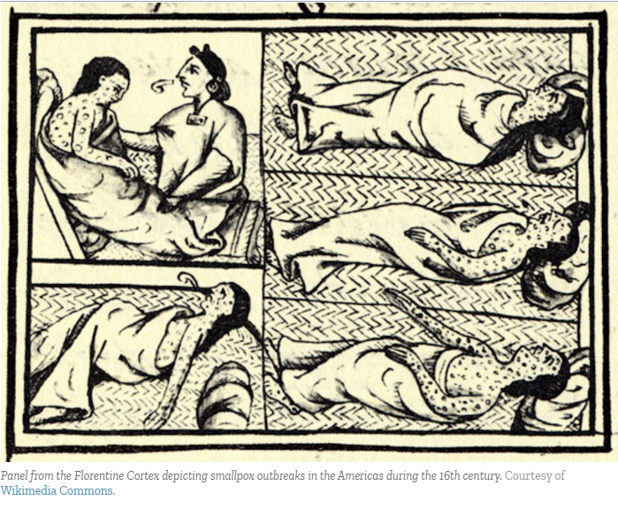

**Prompt 4:** Explain how the growth of the Spanish Empire in North America shaped the development of social and economic structure over time.

**Document for Prompt 4:**

