Technology 1

QUIZ: AutoCAD Lines and Circles

BEFORE THE QUIZ: Create a new folder in your AUTOCAD folder, called

“lastname_autoCAD_TEST_1”.

Save the following figures into this folder, call them DRAWING1.dwg, DRAWING2.dwg, etc.

NOTE: You may use any of the online materials at highlandtechnology.org to assist you, as needed!

REMEMBER THE FIRST RULE OF AUTOCAD: Start with what you know how to do without making any mistakes, then build from there!

PROBLEM 1- Use the LINE command to draw a design using the following Point Coordinates. Save this as DRAWING1.dwg (25 Points)

Point | Coordinates
1 | 2,2
2 | @2,0
3 | @2<90
4 | @2,-2
5 | 8,2
6 | @6<90
7 | @-2,0
8 | @2<270
9 | @-2,2
10 | @2<180
11 | @6<270

PROBLEM 2- Using the LINE and CIRCLE commands, as well as the OBJECT SNAP tool, replicate this figure.

(NOTE: The OUTSIDE FIGURE IS A PERFECT SQUARE!)

Save this as DRAWING2.dwg. (25 Points)

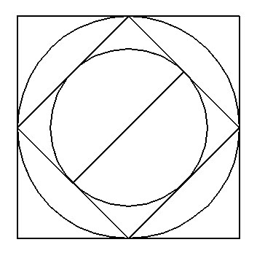

PROBLEM 3- Using the LINE and CIRCLE commands, replicate the following figure. Save this as DRAWING3.dwg. (25 points)

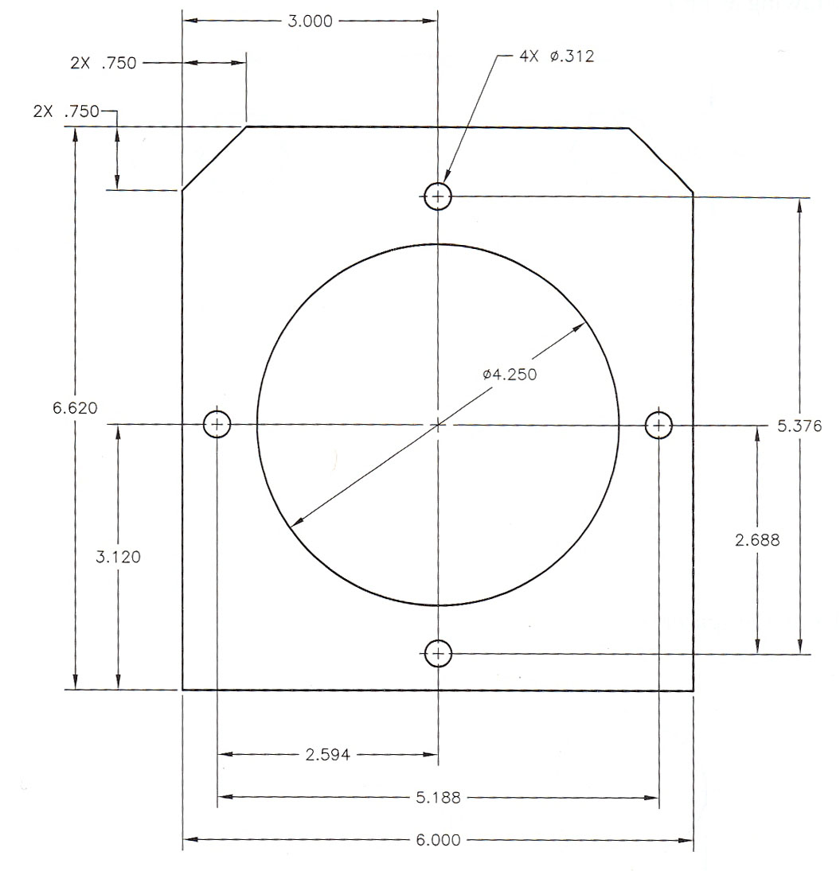

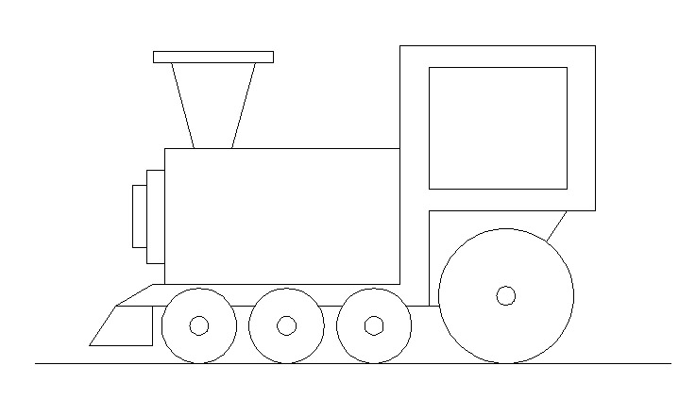
PROBLEM 4- Using the LINE, CIRCLE and TRIM Commands, replicate the figure below as accurately as possible. Save this as DRAWING4.dwg. (25 Points)

SUBMITTING YOUR TEST: When you have completed all 4 problems of the examination and saved them to your “lastname_autocad_test_1” folder, please use “MY COMPUTER” to COPY this folder to Mr. B.’s DROPBOX Folder for your class.

