Technology 1

Test: AutoCAD Lines and Circles

BEFORE THE TEST: Create a new folder in your AUTOCAD folder, called

“lastname_autoCAD_TEST_1”.

Save the following figures into this folder, call them DRAWING1.dwg, DRAWING2.dwg, etc.

NOTE: You may use any of the online materials at highlandtechnology.org to assist you, as needed!

REMEMBER THE FIRST RULE OF AUTOCAD: Start with what you know how to do without making any mistakes, then build from there!

PROBLEM 1- Use the LINE command to draw a design using the following Point Coordinates. Save this as DRAWING1.dwg (20 Points)

Point | Coordinates
1 | 2,2
2 | @2,0
3 | @2<90
4 | @2,-2
5 | 8,2
6 | @6<90
7 | @-2,0
8 | @2<270
9 | @-2,2
10 | @2<180
11 | @6<270

PROBLEM 2- Using the LINE and CIRCLE commands, as well as the OBJECT SNAP tool, replicate this figure.

Save this as DRAWING2.dwg. (20 Points)

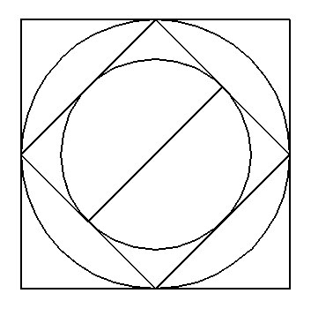

PROBLEM 3- Using the LINE and CIRCLE commands, replicate the following figure. Save this as DRAWING3.dwg. (20 points)

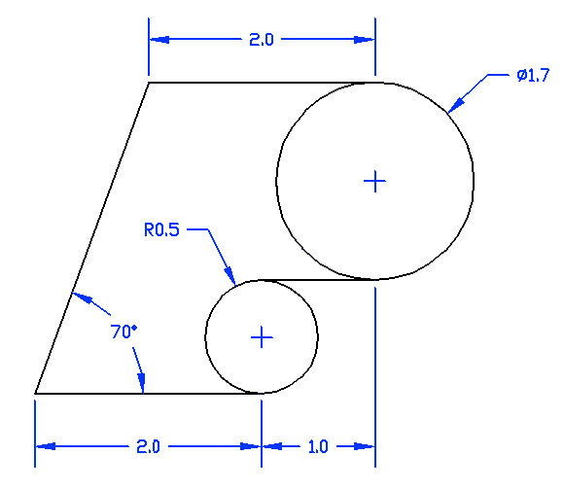

PROBLEM 4- Using the LINE, CIRCLE and TRIM Commands, replicate this figure below as exactly as possible. Save this as DRAWING4.dwg. (20 Points)

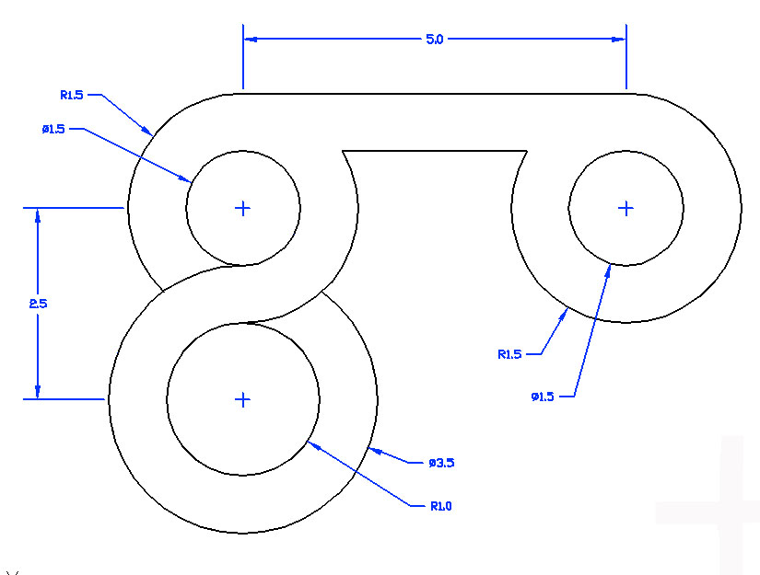

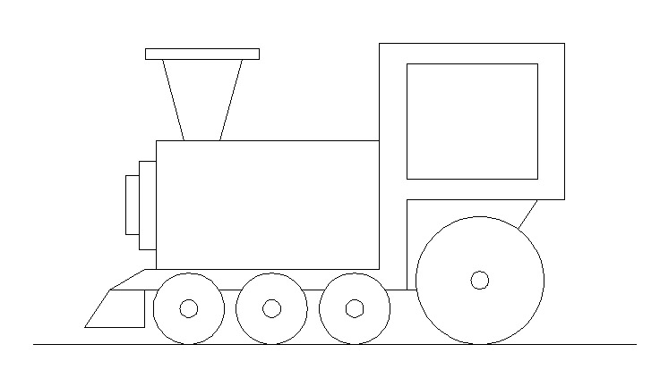
PROBLEM 5- Using the LINE, CIRCLE and TRIM Commands, replicate the figure below as accurately as possible. Save this as DRAWING5.dwg. (20 Points)

EXTRA CREDIT CHALLENGE PROBLEM: Replicate this figure, using any methods at your disposal. Save as extracredit.dwg. (worth up to 20 extra credit points.)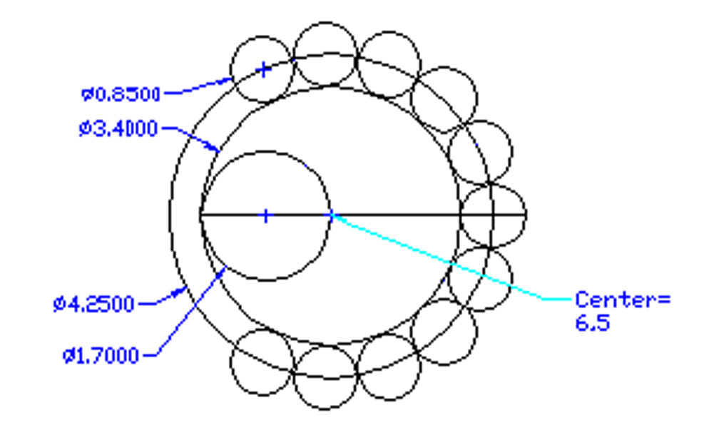

SUBMITTING YOUR TEST: When you have completed all 5 problems of the examination and saved them to your “lastname_autocad_test_1” folder, please use “My Computer” to COPY this folder to Mr. B.’s M: Drive Drop Box Folder for your class.

ONCE YOU HAVE COMPLETED THE TEST: Please go to the class webpage and begin work on today’s extended writing entitled “THE MAN.” The link for this assignment is on the webpage for today.

