Technology 1
September 10/11, 2007

Practice Test, AutoCAD Lines and Circles

Create a new folder in your AUTOCAD folder, called “lastname_910_practice_test” or “lastname_911_practice_test”. Save the following figures into this folder, call them figure1.dwg, figure2.dwg, etc.

FIGURE 1- Use the LINE command to draw the following graphic design using the following Point Coordinates. Save this as DRAWING1.dwg
Point | Coordinates
1 | 2,2
2 | @1.5,0
3 | @.75<90
4 | @1.5<0
5 | @0,-.75
6 | @3,0
7 | @1<90
8 | @-1.5,0
9 | @0,1.25
10 | @-1.25,1.25
11 | @2<180
12 | @-1.25,-1.25
13 | @2.25<270

FIGURE 2- Use the LINE command to draw the following figure. Use the SNAP and GRID commands, set at 1.0 unit per grid, to help with your drawing. Save this as DRAWING2.dwg
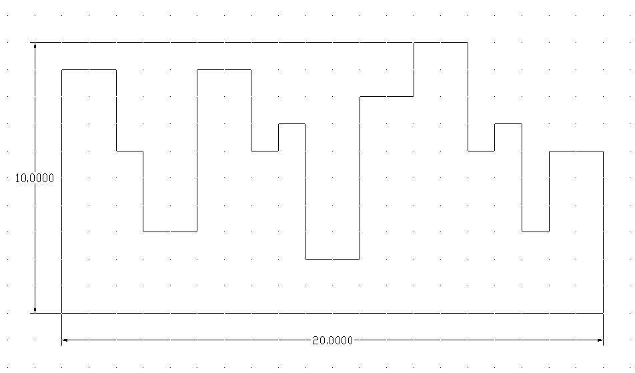

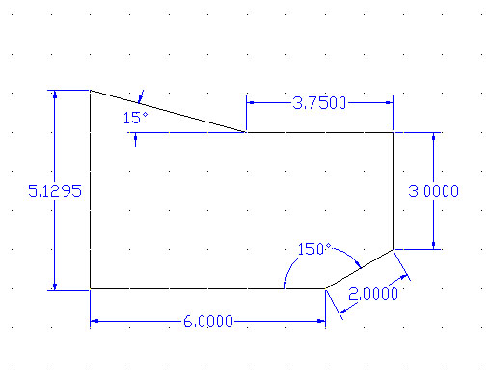
FIGURE 3- Use the LINE command and POLAR TRACKING to draw the figure below. Make sure your POLAR TRACKING is set to 15°. Save this as DRAWING3.dwg.

FIGURE 4- Using the LINE and CIRCLE command, replicate this figure. Save this as DRAWING4.dwg.

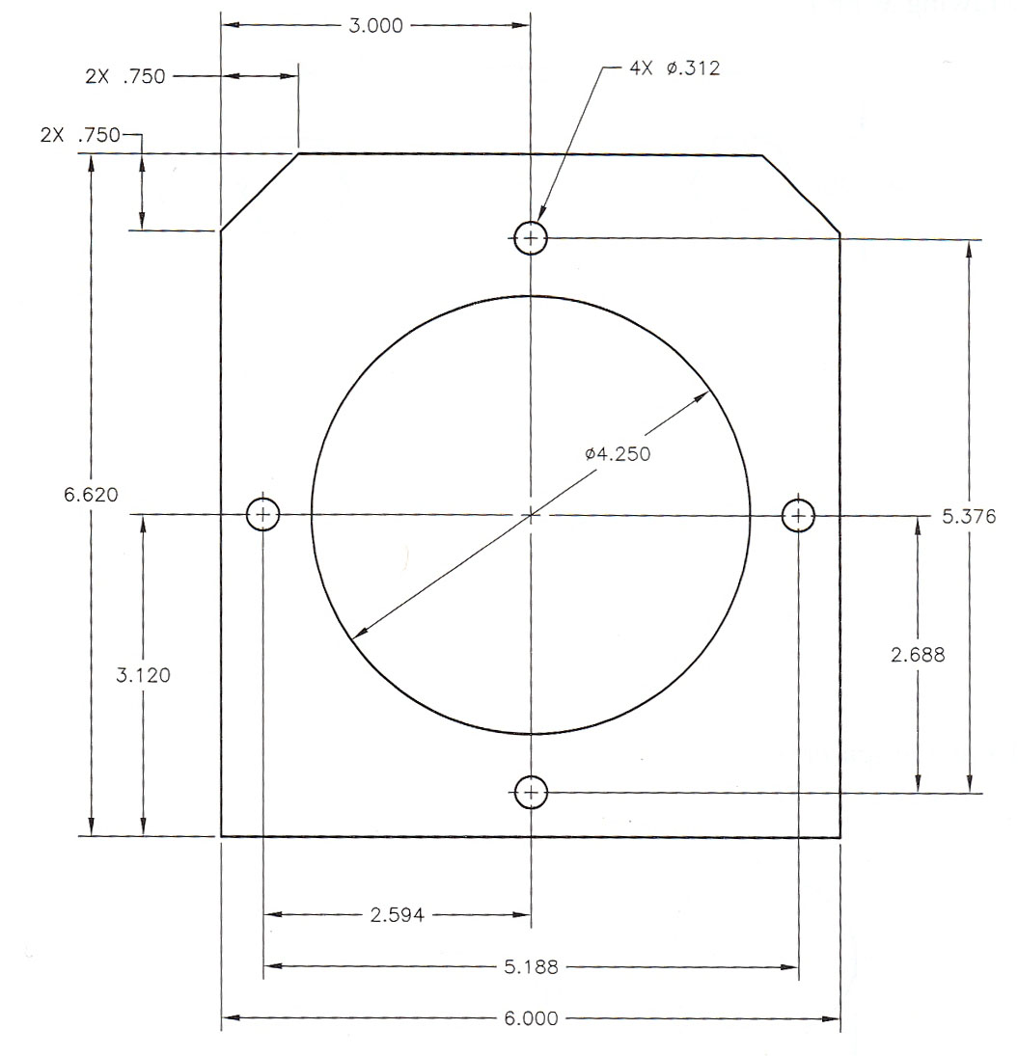

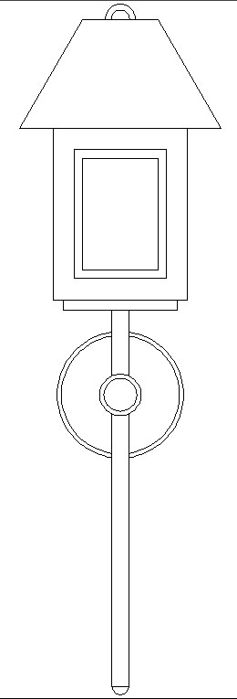
FIGURE 5- Using the LINE, CIRCLE and TRIM Commands, replicate this figure as exactly as possible. You can leave off the horizontal lines at the top and bottom of the figure. Save this as DRAWING5.dwg.

