Technology 1

Daily Assignment 930/1001, AutoCAD Self-Learning (COPY, MOVE, OFFSET, ROTATE, RECTANGLE, POLYGON, ELLIPSE.)

First, create a “lastname_930/1001” folder on your network space for this assignment. Save all of the following drawings into this folder.

Practice Problems:

DRAWING 1:
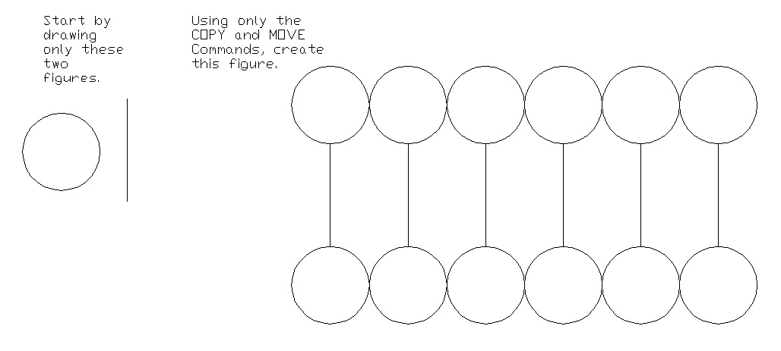
DRAWING 2:
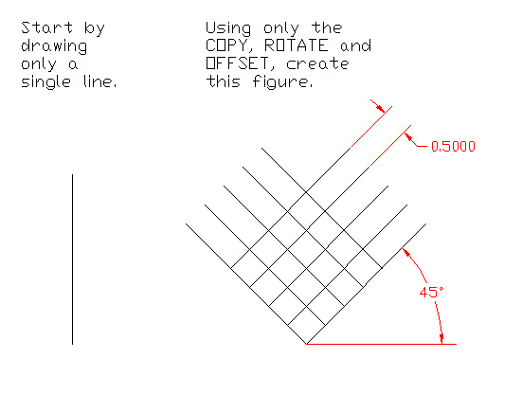
DRAWING 3: (USE THE EDGE SUBCOMMAND OF POLYGON ON THIS PROBLEM!)
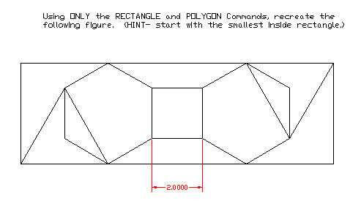
DRAWING 4:
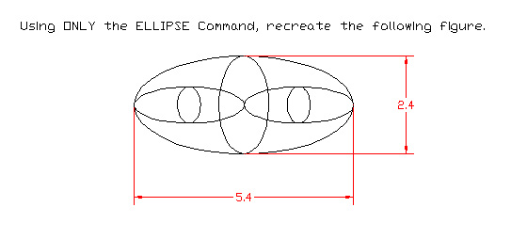

DRAWING 5 (FILLET Command): Red Book, Page 217, Problem 1: (Start with the LINE or the RECTANGLE command to make the outside square, use OFFSET to create the inside squares, then use FILLET to round all the corners.)

DRAWING 6: Page 222, Problem 10. (Use OFFSET to draw the double lines. Don’t worry about the text in this problem, but do try to do the problem as listed in the book, create the “furniture” off to the side, then COPY and MOVE or ROTATE the pieces into the “office”.

DRAWING 7: Page 122, Problem 3. Recreate the three figures in the center of the page using ONLY the POLYGON command.

DRAWING 8: Page 182, Problem 5. (Recreate the drawing on the right, of a stovetop. Use POLAR ARRAY, FILLET and COPY as needed.)

DRAWING 9: Page 957, Problem 75. (Use FILLET where you can, in some cases, you might have to use TTR Circles and TRIM instead of using FILLET. Use the POLYGON command to create the center Octagon.)

SUPER TOUGH LOOKING CHALLENGE PROBLEM, DRAWING 10: Page 397, Figure 26-7. (Recreate this figure in TWO DIMENSIONS. NOTE the line at the bottom that says that all ROUNDS [circles] are R.40 and all FILLETS are R.10. Mr. B. has not done this problem before, so you are on your own, haha!)

COPY your “lastname_930/1001” folder to Mr. B.’s M: Drive Drop Box Folder (now called “hsdropbox”) for your class period.

