Technology 1

Daily Assignment 910/911, Polar Tracking and AutoCAD REVIEW.

The following has a few POLAR TRACKING problems, as well as more opportunities to practice LINE, CIRCLE, TRIM and OSNAP.

Create a “lastname_910” or “lastname_911” folder on your network space. Save all of the following drawings into this folder.

Replicate the following figures:

DRAWINGS 1 and 2: Page 78, Problems 2-3. Do these problems WITHOUT the mouse, please. These problems will help you practice “@distance<angle”, which will be needed for the test. Remember:

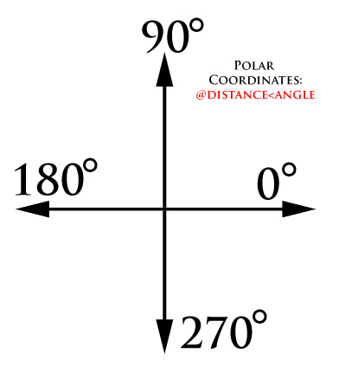

DRAWING 3: Page 81, Problem 7. (Use the POLAR TRACKING set at 15 degrees to find all of the centers for the circles of this problem.)

DRAWING 4: Page 51, Problem 1. (Use the OBJ SNAP-QUADRANT here.)

DRAWING 5: Page 140, Problem 3. (Just draw the figure, don’t worry about the dumb book instructions and the 3D stuff.)

DRAWING 6: Page 101, Problem 1. (You have done a problem just like this already, but now complete it with numbers on the drawing to guide you.)
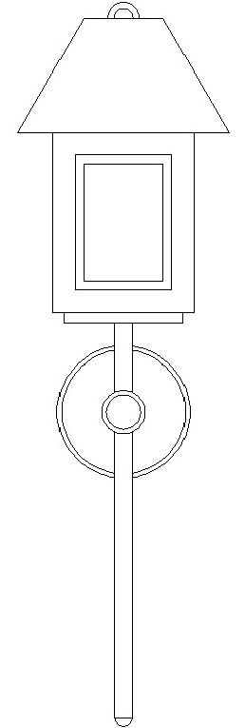
DRAWING 7: Page 122, Problem 2. (Again, use OBJ SNAP-QUADRANT on this problem. Lots of trimming is needed, as well.)

DRAWING 8: Recreate the figure to the right to the best of your abilities. (Use circle, line and trim and a bunch of educated guesses to make the lamp as perfect as possible.)

DRAWING 9: Page 68, Problem 2, (Just draw the second house, not the first one.)DRAWING 10-12: Page 136, RECREATE Figures 10-7 through Figure 10-9 on this page. (Please recreate each of these THREE drawings, they MUST look exactly as in the book when completed.)

EXTRA CREDIT BONUS ACTION SPECIAL: Complete this problem to show your AutoCAD prowess: Page 922, Problem 33. Save to the DROPBOX as “lastname_extracreditbonusactionspecial.dwg” for extra credit bonus suckup points.

