Technology 1
August 30/31, 2007

Daily Assignment, AutoCAD Lines, Circles, Trim

GRID AND SNAP PRACTICE:

DRAWING

1: Using any LINE drawing options at your disposal, replicate the following figure:

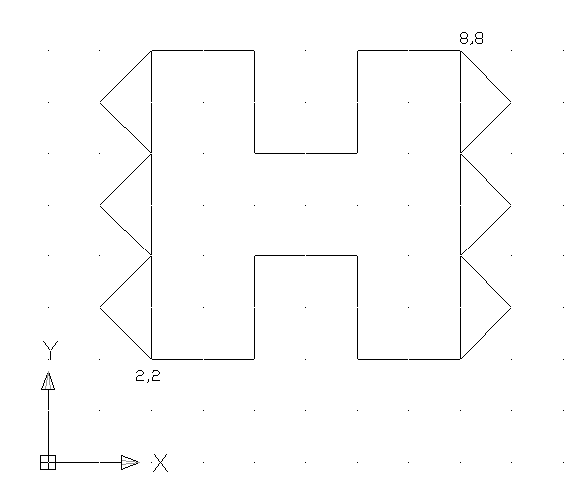
Use the SNAP and the GRID buttons at the bottom of your AutoCAD screen.
Save the figure to your folder as Drawing 1.

DRAWINGS 2-7: From the RED BOOK, replicate the following figures (Save them as Drawing2, Drawing3, etc.):

PAGE 31, Problems 1-2
PAGE 32, Problems 3-4
PAGE 33, Problems 1-2: Save BOTH of these problems to your folder, the second problem is a modification of the first problem.

POLAR COORDINATES PRACTICE:

DRAWINGS 8-10: From the RED BOOK, replicate the following figures:

PAGE 78, Problems 2-3
PAGE 79, Problem 5.

CIRCLES and TRIM PRACTICE:

DRAWINGS 12-14

PAGE 79, Problem 4
PAGE 80, Problem 6
PAGE 81, Problem 7
PAGE 82, Problem 1

When you have completed all 14 problems, copy your entire “Lastname_8-30” folder to the M: Drive Drop Box for your class period.

