Technology 1

Daily Assignment 1014/1015, AutoCAD Isometrics.

First, create a “lastname_1014/1015” folder on your network space for this assignment. Save all of the following drawings into this folder.

DRAWING 1: Red Book, Page 515, Figure 35-12B: (Replicate this figure, estimate dimensions.)

DRAWING 2: Page 514, Figure 35-9.

DRAWING 3: Page 515, Figure 35-10.

DRAWING 4: Page 515, Figure 35-11

DRAWING 5: Page 513, Figure 35-8 (Replicate this figure, use all given dimension for this drawing, estimate the size of the circles.)

DRAWING 6: Replicate the drawing below. Use the dimensions as given.
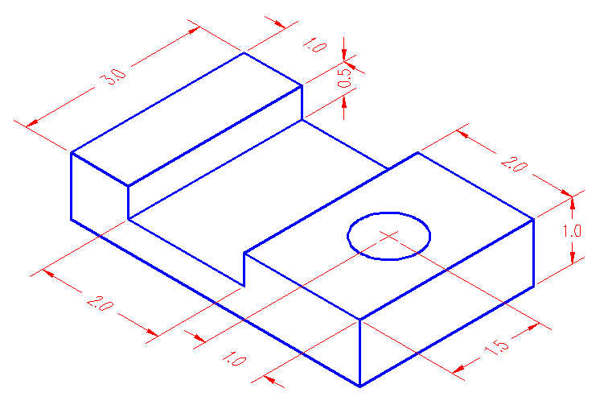
DRAWING 7: Replicate the drawing below. Estimate all dimensions.
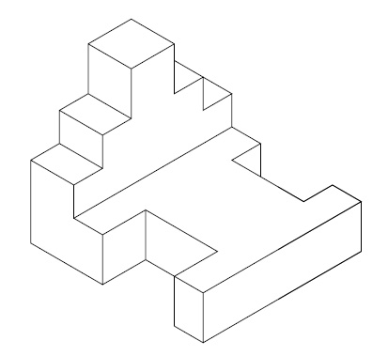

DRAWING 8: Replicate the drawing below. Use the COPY command to create the inside “thickness” of the isocircles. Use lots of TRIM.

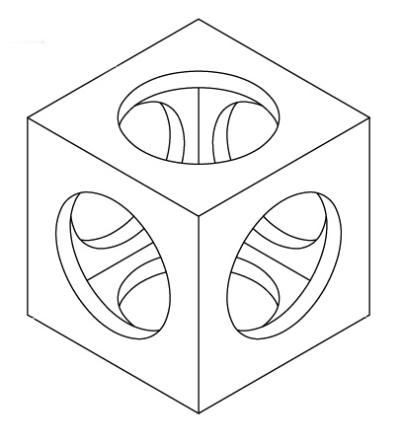

KINDA HARD CHALLENGE PROBLEM, DRAWING 9: Use the dimensions shown in the left side figure to create the isometric drawing on the right.

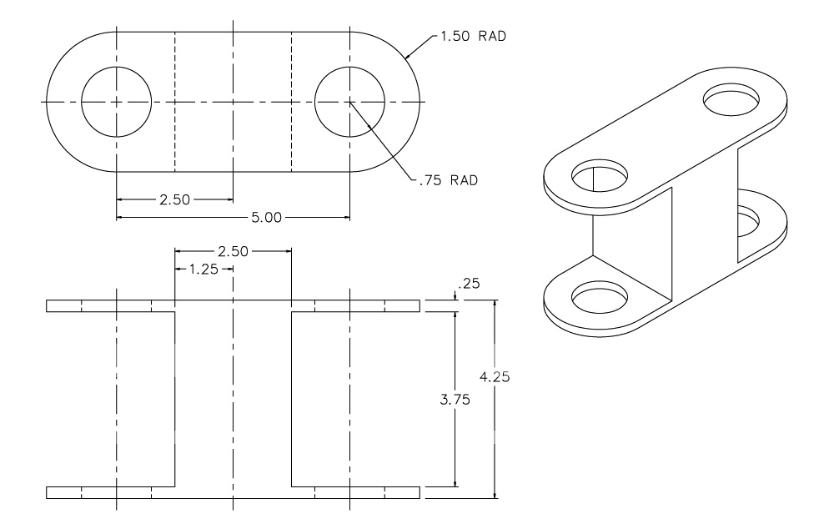

COPY your “lastname_1014/1015” folder to Mr. B.’s M: Drive Drop Box Folder (now called “hsdropbox”) for your class period.

