Technology 1

AutoCAD Daily Assignment ONE, Line Command

BEFORE YOU START: Create a new folder in your AUTOCAD folder, called “lastname_AUTOCAD_1”. Save the following figures into this folder, call them figure1.dwg, figure2.dwg, etc.

FIGURE 1- Use the LINE command to draw the following graphic design using absolute coordinates:
- LINE>Enter
- 1.5,5.75
- 3.25,5.75
- 3.25,4.5
- 5,6.375
- 3.25,8.25
- 3.25,7
- 1.5,7
- 2.125,6.375
- 1.5,5.75
- Enter to Cancel the Line Command
- Save drawing to your folder as figure1.dwg

FIGURE 2- Use the LINE command to draw the following figure using absolute coordinates:
- 2,2
- 4,2
- 4,3.5
- 3,3.5
- 3,4
- 2,4
- 2,2
- ENTER to Cancel the Line Command
- LINE>Enter
- 2,2.75
- 4,2.75
- ENTER to Cancel the Line Command
- LINE>Enter
- 3,2
- 3,2.75
- ENTER
- Save drawing to your folder as figure2.dwg

FIGURE 3- Use the LINE command to draw the sheet metal part using the following relative coordinates after the initial absolute coordinates:
- LINE>Enter
- 2, 2 (absolute)
- @3.25,0
- @0,1.875
- @-.875,0
- @0,.75
- @1.75,0
- @0,3.125
- @-.5,.5
- @-1.5,0
- @-.75,-.75
- @-.75,.75
- @-.25,0
- @0,-2
- @.25,0
- @0,-3.5
- @-.25,-.25
- @-.375,0
- Close
- Save the drawing to your folder as figure3.dwg

FIGURE 4- Use the Line Command to draw the following figure using relative coordinates:

- LINE>Enter
- 6,2 (absolute)
- @2,0
- @0,2
- @-.75,0
- @0,-1.25
- @-1.25,0
- @0,-.75
- ENTER to Cancel Line Command.
- Save Drawing to your folder as figure4.dwg

FIGURE 5- Use the LINE command to draw the latch plate using the following polar coordinates after the initial absolute coordinate:
- LINE> Enter
- 3,4 (absolute)
- @.5<0
- @.625<90
- @2.5<0
- @2.375<90
- @.75<180
- @1.5<270
- @2.25<180
- @.75<225
- @.375<270
- Close
- Save the drawing to your folder as figure5.dwg

FIGURE 6- Use the LINE command to draw the trophy base using the following polar coordinates:
- LINE>Enter
- 3,4 (absolute)
- @2<45
- @2<315
- @1.5<270
- @2.8284<180
- @1.5<90
- Enter to cancel the Line Command
- Save the drawing to your folder as figure6.dwg

FIGURE 7- Use the LINE command to draw the trophy base using the following combination of coordinates:
- 1.5,3 (absolute)
- @5,0 (relative)
- @1<90 (polar)
- @5<180 (polar)
- Close
- Press Enter or Space Bar
- 2.25,4 (absolute)
- @4.5<90 (polar)
- @1.75, 1.75 (relative)
- @1.75,-1.75 (relative)
- @4.5<270 (polar)
- Cancel
- Press Enter or Space Bar
- 2.75,4.75 (absolute)
- @2.5,0 (relative)
- @3.5<90 (polar)
- @2.5<180 (polar)
- Close
- Save the drawing to your folder as figure7.dwg

FIGURE 8- Use the LINE command to draw the picture frame using the following combination of coordinates:
- Point 1: 1,1 (absolute)
- Point 2: @6.5,0 (relative)
- Point 3: @9<90 (polar)
- Point 4: @-6.5,0 (relative)
- Close
- Press Enter or Space Bar
- Point 5: 1.5,1.5 (absolute)
- Point 6: @5.5,0 (relative)
- Point 7: @8<90 (polar)
- Point 8: @5.5<180 (polar)
- Close
- Make sure that the Gray OBJ SNAP Button at the bottom of the screen is turned ON
- Press Enter or Space Bar
  - Click Point 1 (Points as defined in the problem above)
  - Click Point 5
  - Cancel
- Press Enter or Space Bar
  - Click Point 2
  - Click Point 6
  - Cancel
- Press Enter or Space Bar
  - Click Point 3
  - Click Point 7
  - Cancel
- Press Enter or Space Bar
  - Click Point 4
  - Click Point 8
  - Cancel
- Save the drawing to your folder as figure8.dwg

FIGURE 9- Create a listing of all of the steps required to create the following figure. (NOTE that the figure STARTS at point 2,2). Please use all methods of Line Creation in this exercise: Polar, Relative and Absolute.

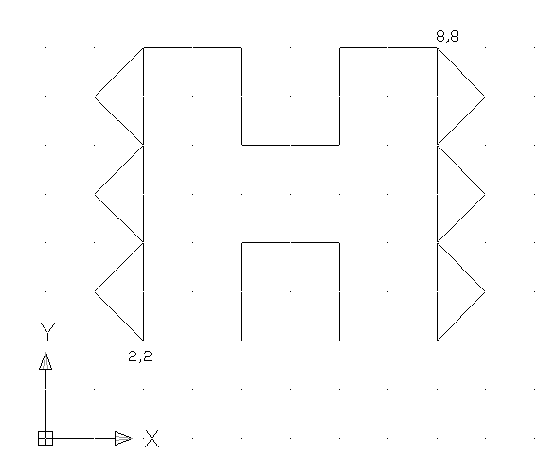
Save the figure to your folder as Drawing 9.

Problems 10-14: From the RED BOOK, replicate the following figures: PAGE 31, Problems 1-2 and PAGE 32, Problems 3-4.

SUBMITTING YOUR WORK: When you have completed all 13 problems, copy your entire “Lastname_8-28/29” folder to the M: Drive Drop Box for your class period.

