Technology 1

AutoCAD Final Project- “The Dream House”

PREMISE: An unknown aunt from a distant corner of your family, Aunt Babby, has recently passed away. A lawyer delivers you a court document, stating that Aunt Babby has left you the sum of 5.6 million dollars and a 16 acre parcel of land in the mountains outside of Steamboat Springs, Colorado. The property is nicely wooded, with rock outcroppings and a small stream running through the grounds. There is a nice, level area of ground 300 feet by 200 feet that would be perfect for building a house.

Because you love AutoCAD so much, you have decided that you will not only build your Dream House on this location, but also DESIGN the house, using your architectural drawing skills.

THE PROJECT: As your final project in AutoCAD, you will be creating your Dream House. This project will be worth 200 points. To begin this project, you must first complete all four problems on Daily Assignment 1023/1024.

RULES FOR YOUR PROJECT:

- Your house will contain NO FEWER than 10 rooms, as follows:
  - TWO GUEST BEDROOMS, with closets in each room.
  - ONE MASTER BEDROOM (Double size of the other bedrooms, with a bathroom, and extra large closet.)
  - KITCHEN, with sinks, counters, Refrigerators, Dishwasher, etc.
  - TWO Bathrooms, each with a toilet and tub/shower.
  - FAMILY ROOM, with large windows for seeing the property and a fireplace.
  - DINING ROOM, with table and 10 chairs.
  - GAME ROOM, furnished with some of the following, according to your tastes: pool table, poker table, wet bar, dart boards, dance floor, etc.
  - HOME THEATER, with room for couch seating for at least 10 guests.
  - AT LEAST ONE EXTRA ROOM of your choice, this can be anything from an indoor pool to a basketball court to a bowling alley.
- Before you begin drawing your house in AutoCAD, you MUST complete a pencil drawing of the layout of your house. This rough draft will be worth 50 points towards your final project grade. Include all elements listed above in your rough draft, as well as basic dimensions.
- When you start drawing your house, make sure you use Wizards to create a page that is at most 300’ x 200’ on which to draw your house.
- CREATE TWO NEW LAYERS for your drawing:
  - HOUSE LAYER (black): includes all of the walls, doors, sinks, appliances and windows of the house.
  - TEXT LAYER (green): includes all of the Room labels, explanatory text and dimension lines.
- All walls (double lines) will be 6” thick on your drawing.
- All rooms will have proper doors and windows, as outlined in AutoCAD Assignment TEN.
- All rooms will be properly labeled: “LIVING ROOM”, “GAME ROOM”, etc. In addition, room labels will include room dimensions.
- You may find that you cannot fit all of your rooms as you would like them on a single level home. If this is the case, you can create a TWO STORY (or more) house. If you do, be sure to include STAIRWAYS from one level to the next.

THE TITLE BLOCK: When you have completed your project, please draw a large RECTANGLE around your house drawing. In the lower RIGHT corner, please place a TITLE BLOCK that looks like this:
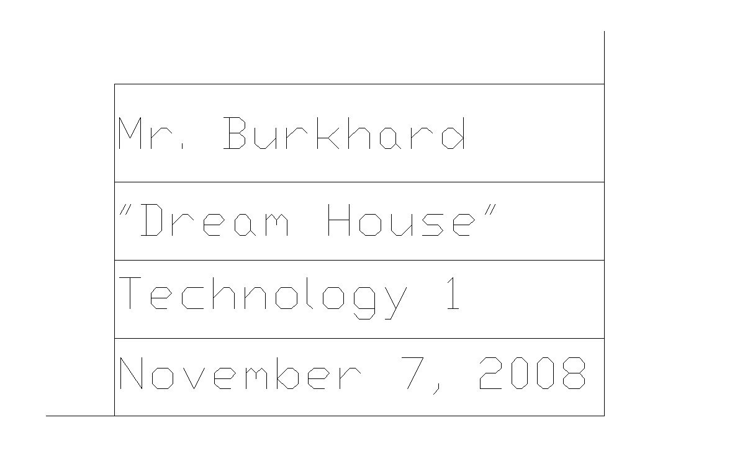

PROJECT SUBMISSION: Turn in your pencil rough draft with your name on it when completed. Save your “lastname_final_project” file and the FOUR files from daily assignment 1024 into a folder called “lastname_final_project” and copy that folder into my DROPBOX when you are done.

GRADING: This project will be graded on the quality and effort of the work put into each of the following categories:
- ROUGH DRAFT (50 Points): Well thought out drawing, includes all major dimensions and all 15 required rooms.
- STRUCTURE (100 Points): Properly executed floor plan, with double lined walls, doors, windows, etc., executed on a HOUSE LAYER in black.
- TEXT and DIMENSIONS (50 Points): All rooms properly labeled and dimensioned on a TEXT LAYER in green. Explanatory text when needed.

DUE DATE: This project MUST BE COMPLETED BY NOVEMBER 7TH FOR ALL CLASSES! If you cannot finish using class time, you must come in during lunch, after school, etc. to complete it. We move on to Fireworks Graphic Design on November 10th!

