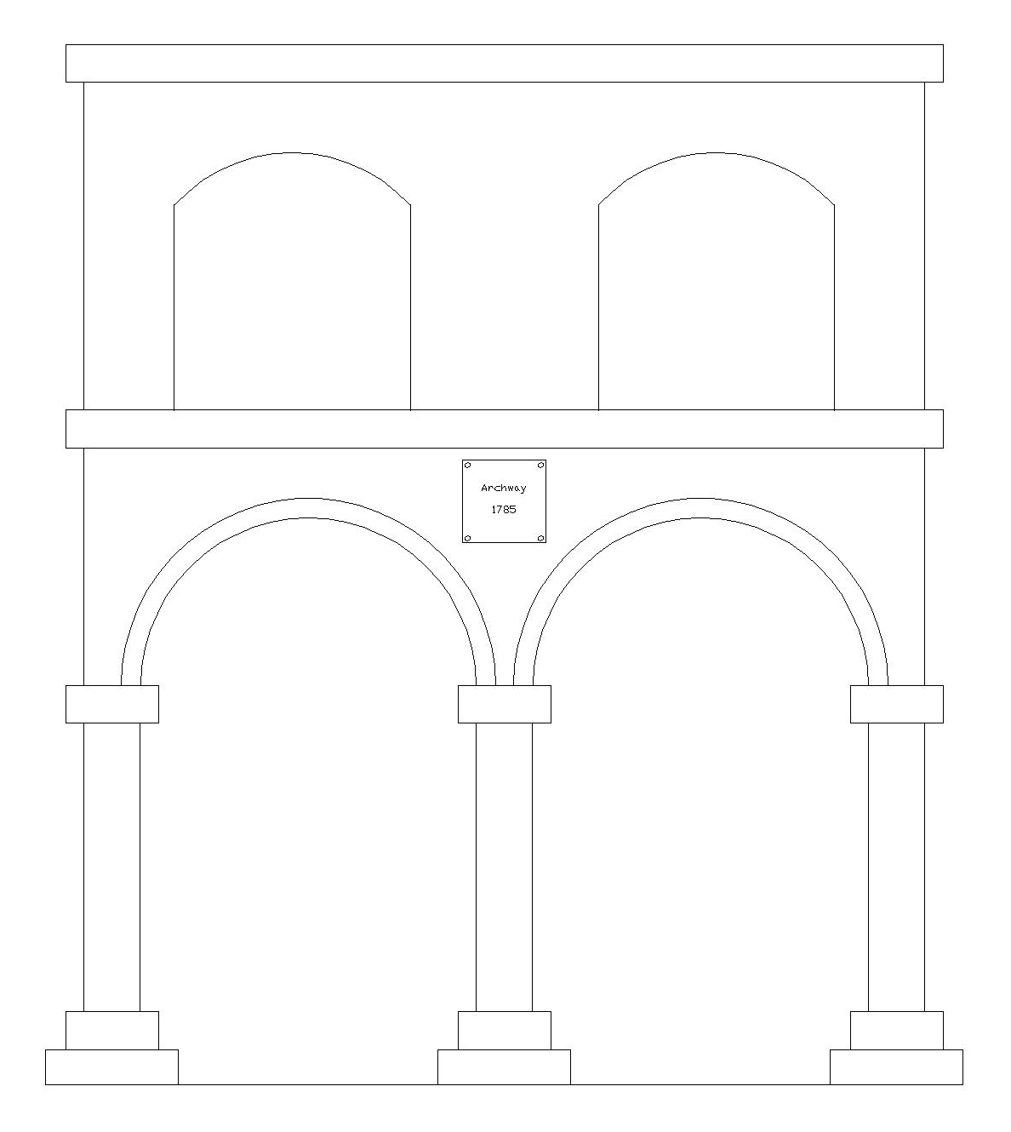

**Technology 1- The Non-Test Midterm Examination: The Archway**