To ALL my Heroes at Highland!!

Wow, do you ever know how to brighten someone’s day!! It would be impossible for me to fully express how grateful I am for all that you have done to support me...YOU can take full credit for why I am feeling so great (ok, maybe you AND my team of surgeons)! Your wonderful messages, “artistic” cards , GENEROUS and clever fundraising, and every ounce of positive energy you sent my way have impacted me more than you will ever know!!! Thank You THANK YOU THANK YOU!!! It would be my great fortune to cross paths with you again someday, and, until then, please know that I will always be your #1 Fan!!!

GO HUSKIES!!!

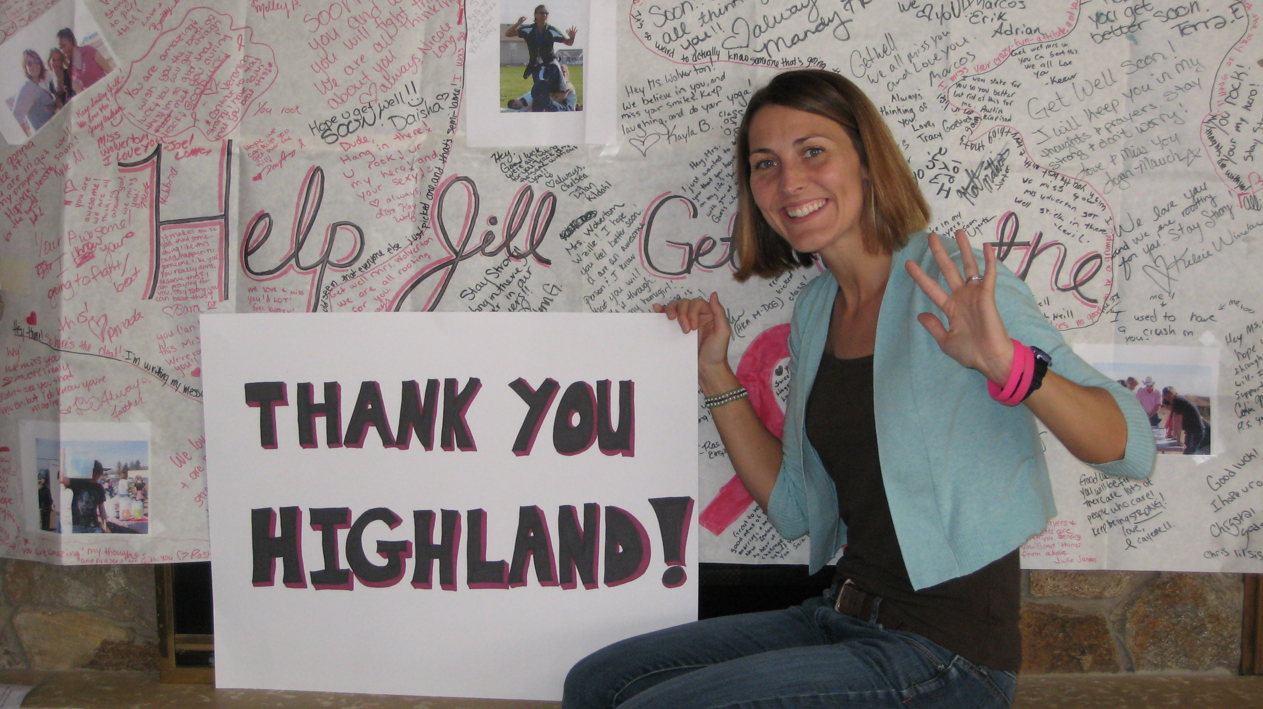
Love,

Jill (Wolverton) Svilar
Aka – “Miss W”

