Graphic Design
September 11, 2007
Removing Images from Backgrounds and the “Moving Animals Assignment”

How do I cut an object out of its background using the Layer Mask Tool?

Removing an object from a picture using Layer Mask (Download hummingbird.jpg and background.jpg):

• Open your picture to be cut out and your background picture.
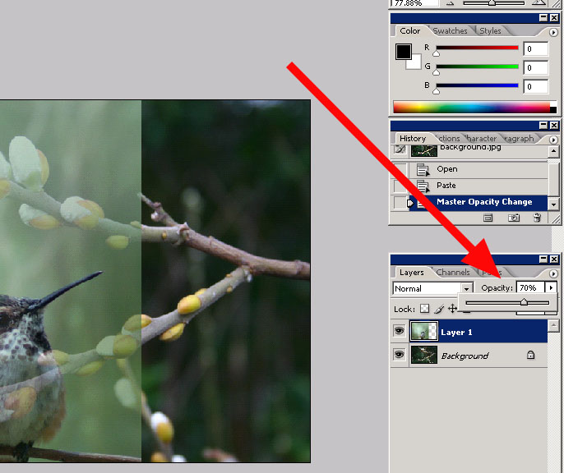
• On the cut out picture, click on “Select>All” and then “Edit>Copy”
• Click on the background picture and Click “Edit>Paste”.
• Set the Opacity of your cut out layer at about 75 percent by moving the Opacity slider in the Layer window (SEE FIGURE).
• Position your cut out layer where it needs to be in respect to the background picture.
• Turn your Opacity for your cut out picture back to 100 percent.

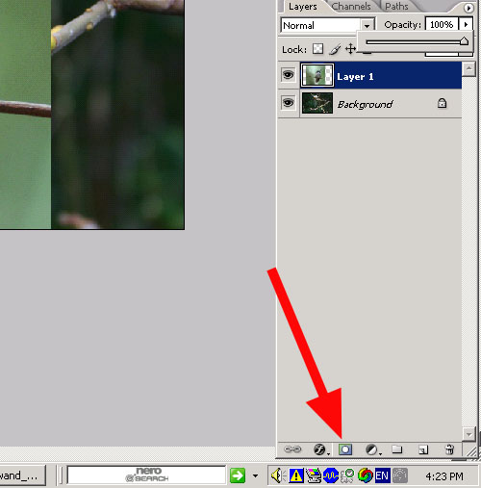
• Click on the “Add Layer Mask” button at the bottom of the Layer Window (small gray rectangle with a white circle in it.) (SEE FIGURE)

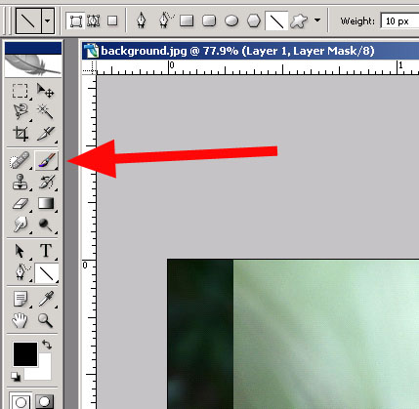
• Click on the “Brush Tool” icon.

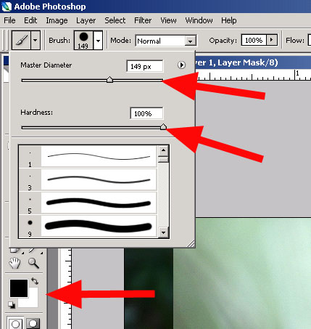
- Set your Brush to be 150-200 pixels wide and your Brush Hardness to 100 percent. (SEE FIGURE, TOP TWO ARROWS)

• Make sure your foreground color for your Brush is set to Black. When Brushing on the Mask, the color Black will remove parts of the cutout image. The Color White will restore the cutout image. (SEE FIGURE, BOTTOM ARROW)

• Carefully brush away as much of the background of your picture as you can. The closer you get to your object, the smaller, softer and more transparent your Brush should be.
• To take out the “Halo” effect, set your Brush to 8-12 pixels in width, 10-20 percent hardness and 10-20 percent Opacity. Use frequent small strokes at the edge of your object to take out unwanted border colors.
- When you are done with your work, Click File>Save As and save the picture as a .JPEG file. This will automatically flatten your layers into one picture. You may also wish to save the .PSD file, which preserves all of your layers and operations for later editing, if necessary.

The “Moving Animals” Assignment:

Using the online Public Domain Image resources from highlandtechnology.org or the files that you saved for last week’s “Public Domain Images” Assignment, locate pictures of two different animals or insects and two different landscapes or buildings. Make sure that one of the animals has a uniformly colored background.
- Use the “Magic Wand” effect to cut one of your animal pictures out of the background and place it into one of your landscapes, in such a way that the animal looks out of place.
- Use the “Layer Mask” effect to cut the other animal out of its background and place it into the other landscape.
This assignment will be worth a total of 50 points. Completed images will be graded on the effect of the composite picture and the precision with which the images were removed from their backgrounds.

