Graphic Design
“The Emotion Painting”
Fractal Effect Tutorial
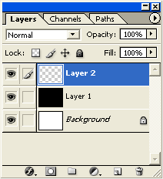
- First, start a new document, set it to 500 by 500 pixels.
- Create a new empty Layer (Shift + Ctrl + N), just above the default document background Layer and fill it with Black (Type the letter “D” to reset your colors to Black and White, then type ALT+BACKSPACE to fill with Black.)
- Create another layer, this time EMPTY above the Black Layer 1. Type CTRL+SHIFT+ALT+N. Your Layers Palette should look like the one to the right.
- Next, select the 'Gradient Tool’ on the Toolbar (or hit the letter G).
  - Notice up on the Options Bar for the Gradient Tool, there are new options that are available. Particularly, the 'Gradient Preset Picker', the five Gradient Styles, and the Blend Mode in which to apply the gradient.
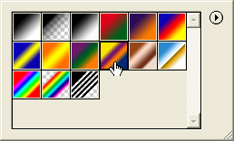
  - Select the 'Gradient Preset Picker' to define the gradient to use for this effect. For this first attempt at fractal painting, use the 'Yellow, Violet, Orange, Blue' preset as shown to the right.
  - Then, just to the right of the Gradient Preset Picker, select the second style called 'Radial Gradient'.
  - Set the Blend Mode to 'Difference'. This will change how the two layers you are creating interact with each other.
- Next, with Layer 2 and the Gradient Tool active, click and drag a single radial gradient somewhere in the center of your document. It should look like the picture at the TOP on the next page.
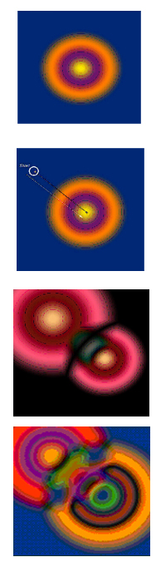
- Next, start a new click and drag radial gradient from just outside the rings toward the center, similar to the look of the second picture. Note: There's no particular goal here, and each click and drag action creates something random. So, at any stage you can always duplicate the Layer for further experimentation.
- This will achieve a result similar to the third picture.
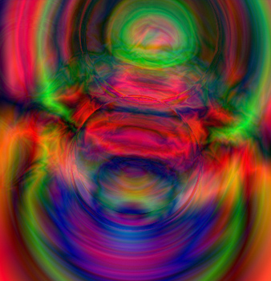
- Keep click and dragging gradients to create a more and more complex images. Here is a sample of a possible final image:

- This was your first attempt. Complete FOUR more. Always follow the same starting steps, creating the new layers.
- For your FOUR NEW ARTWORKS ,experiment with some different color gradients and with some different Gradient Styles, such as the Linear Gradient or the Angle Gradient. Become familiar with which gradients give you smooth curves and which give you harsh lines. You can also change the Blending mode for the gradient to “EXCLUSION” instead of “DIFFERENCE” for a more subtle pastel look. (You can try other Gradient Blends, but they likely won’t work.)
- Try adding additional layers, and putting new gradients on top of other gradient layers and changing the Blending Mode (the dropdown box that says NORMAL at the top of the Layer window) for the layers to something like Hard Light or Color Burn.
- Try adding in some Filter Effects to some of your layers, such as Filter>Artistic>Plastic Wrap or Filter>Distort>Ripple.
- When you have created a total of FIVE pieces of art that you are pleased with, create a final artwork. This will be your EMOTION PAINTING. Using the words, sounds, colors and shapes that we discussed at the beginning of class, create a painting that shows your emotion. Use varied gradients, colors, Filters, etc. to create your painting. When you are done, put your EMOTION, YOUR NAME and the year in the lower right corner of your work. SAVE your EMOTION PAINTING to your “lastname_tutorials” folder it “lastname_emotion”, this will be a 25 point assignment.
- Here is Mr. B.’s painting, entitled “Depression”:
