Juicy Guts Photoshop Tutorial
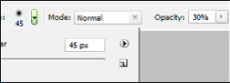

Step 1:
To start off, create a new document 500x500px with a white background. To get a white background, make sure that your Foreground Color is set to white, then hit “Alt-Backspace” to fill your canvas.
Step 2:
Select the Brush Tool and a soft rounded brush with a diameter of 45px. Set both the Opacity and the Flow to 35%.
Step 3:
Next, set the Foreground Color to #660000. Click on the Foreground Color Swatch and in the small window next to the # sign, type in “660000.”
Step 4:
Use the Brush Tool to scribble on your white canvas until it looks like something in the picture to the right
Step 5:
Set the Foreground Color to #990000 and scribble some more onto your canvas.
Step 6:
Set your Foreground Colour to #CC0000 and keep on scribbling on the canvas. Make sure to cover as much of the canvas as you can, leaving only a few small white areas. You should now have something that looks like this.
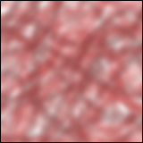
Step 7:
Now select “Filter>Artistic>Plastic Wrap.
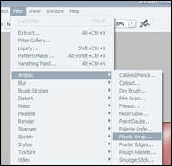
Step 8:
Set the “Highlight Strength” to 5, and “Detail” to 15 and “Smoothness” to 5.
Step 9:
After you have applied them settings, click on “Image>Adjustments>Brightness/Contrast” and set the “Brightness” to –25 and the “Contrast” to +40.
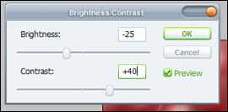
Step 10:
If you have followed all the steps in this tutorial correctly you should have something that looks like this.
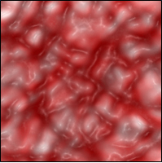
Juicy Guts!

