Graphic Design, September 19, 2006
Emotion Painting
Fractal Effect Tutorial
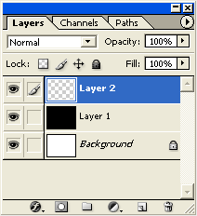
- First, start a new document, set it to 500 by 500 pixels.
- Create a new empty Layer (Shift + Ctrl + N), just above the default document background Layer and fill it with Black (Type the letter “D” to reset your colors to Black and White, then type ALT+BACKSPACE to fill with Black.)
- Create another layer, this time EMPTY above the Black Layer 1. Type CTRL+SHIFT+ALT+N. Your Layers Palette should look like the one to the right.
- Next, select the 'Gradient Tool (G)' on the Toolbar.
  - Notice up on the Options Bar for that particular tool, there are new options that are available. Particularly, the 'Gradient Preset Picker', the five Gradient Styles, and the Blend Mode in which to apply the gradient.
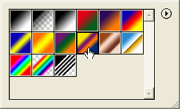
  - Select the 'Gradient Preset Picker' to define the gradient to use for this effect. For this first attempt at fractal painting, use the 'Yellow, Violet, Orange, Blue' preset as shown to the right.
  - Then, just to the right of the Gradient Preset Picker, select the second style called 'Radial Gradient'.
  - Set the Blend Mode to 'Difference'.
- Next with Layer 2 and the Gradient Tool active, click and drag a single radial gradient somewhere in the center of your document. It should look like the picture to the right (TOP).
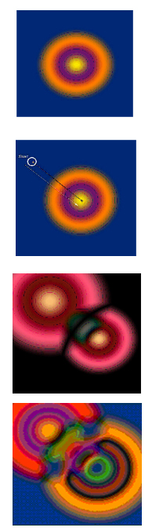
- Next, start a new click and drag radial gradient from just outside the rings toward the center, similar to the picture to the second picture. Note: There's no particular goal here, and each click and drag action creates something random. So, at any stage you can always duplicate the Layer for further experimentation.
- This will achieve a result similar to the third picture.
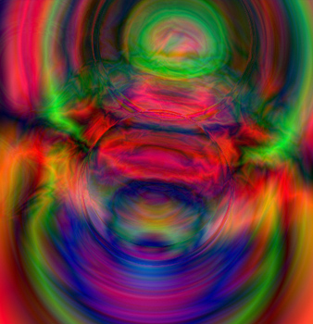
- Keep click and dragging gradients to create a more and more complex images. Here is a sample of a possible final image:

- This was your first attempt. Try some more. Always follow the same starting steps, creating the new layers.
- Experiment with some different color gradients and with some different Gradient Styles, such as the Linear Gradient or the Angle Gradient. You can also change the Blending mode for the gradient to “EXCLUSION” instead of “DIFFERENCE” for a more subtle pastel look. (You can try other Gradient Blends, but they likely won’t work.)
- Try adding additional layers, and putting new gradients on top of other gradient layers and changing the Blending Mode for the layers to something like Hard Light or Color Burn.
- Try adding in some Filter Effects, such as Filter>Artistic>Plastic Wrap or Filter>Distort>Ripple.
- When you have created a couple of nice 5 Minute Artworks that you are pleased with, create a final artwork. This will be your EMOTION PAINTING. Using the words, phrases, colors and feelings that we discussed at the beginning of class, create a painting that shows your emotion. Use varied gradients, colors, Filters, etc. to create your painting. Here is Mr. B.’s painting, entitled “Depression”:
