[1] Take a new file of 400 pixels,400 pixels, of resolution 72 dpi in the RGB mode.

[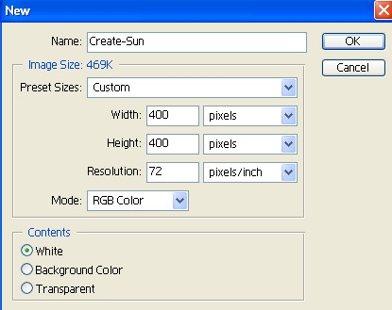](http://www.funphotoart.com/wp-content/uploads/2007/10/fireball-fire-planet-mars1.jpg)

[2] Now create a new layer.

[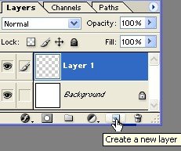](http://www.funphotoart.com/wp-content/uploads/2007/10/fireball-fire-planet-mars3.jpg)

[3] Take the Elliptical Marquee Tool create a shape and fill the color with Black do not deselect.

Use d+ALT+BACKSPACE!!!!!

[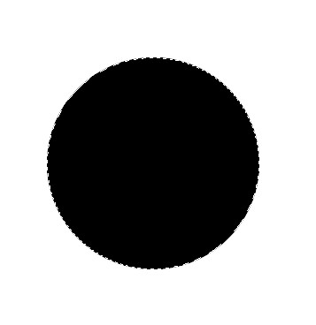](http://www.funphotoart.com/wp-content/uploads/2007/10/fireball-fire-planet-mars5.jpg)

[4] Now go to Filter>Render>Different Clouds.

[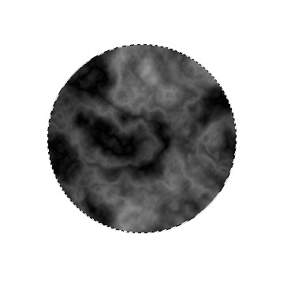](http://www.funphotoart.com/wp-content/uploads/2007/10/fireball-fire-planet-mars7.jpg)

[5] Then press Cntl+L, to Levels apply the following settings.

[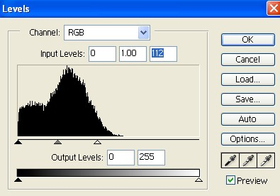](http://www.funphotoart.com/wp-content/uploads/2007/10/fireball-fire-planet-mars8.jpg)

[6] Your image should be look like this.

[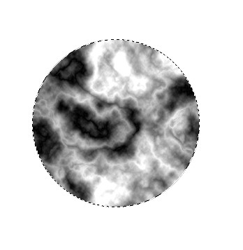](http://www.funphotoart.com/wp-content/uploads/2007/10/fireball-fire-planet-mars9.jpg)

[7] Now go to Filter>Sharpen>Unsharp Mask use these values.

[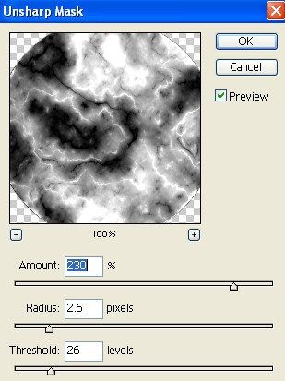](http://www.funphotoart.com/wp-content/uploads/2007/10/fireball-fire-planet-mars10.jpg)

[8] Your image should be look like this.

[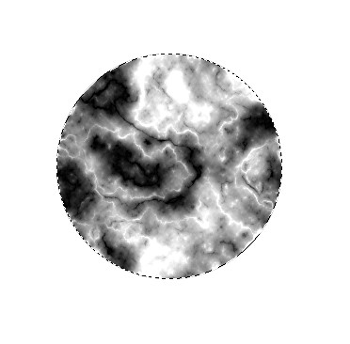](http://www.funphotoart.com/wp-content/uploads/2007/10/fireball-fire-planet-mars11.jpg)

[9] Then go to Filter>Distort>Spherize apply these settings.

[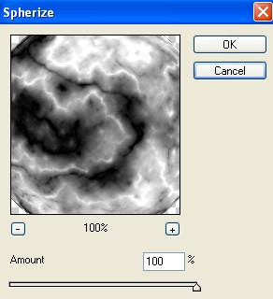](http://www.funphotoart.com/wp-content/uploads/2007/10/fireball-fire-planet-mars12.jpg)

[10] Your image should be look like this.

[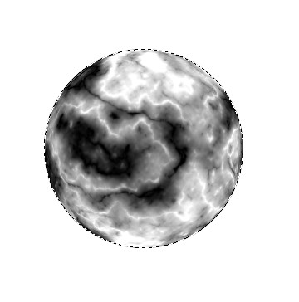](http://www.funphotoart.com/wp-content/uploads/2007/10/fireball-fire-planet-mars13.jpg)

[11] Now press Cntl+B, to Color Balance use these settings.

[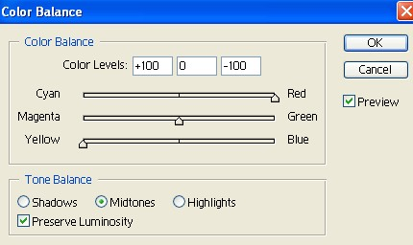](http://www.funphotoart.com/wp-content/uploads/2007/10/fireball-fire-planet-mars14.jpg)  
[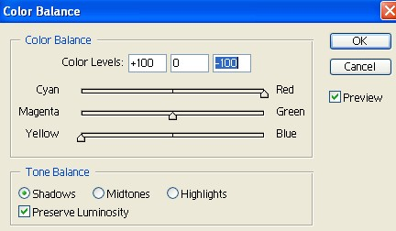](http://www.funphotoart.com/wp-content/uploads/2007/10/fireball-fire-planet-mars15.jpg)

[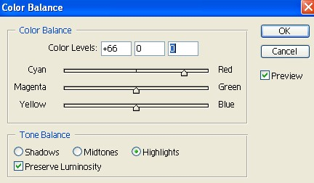](http://www.funphotoart.com/wp-content/uploads/2007/10/fireball-fire-planet-mars16.jpg)  
[12] Your image should be look like this.

[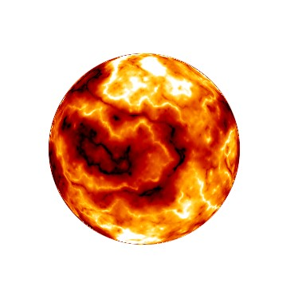](http://www.funphotoart.com/wp-content/uploads/2007/10/fireball-fire-planet-mars17.jpg)

[13] Now select the Background Layer and fill the color with black and go to Filter>Noise>Add Noise use these settings.

[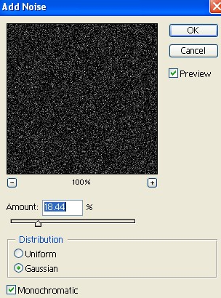](http://www.funphotoart.com/wp-content/uploads/2007/10/fireball-fire-planet-mars18.jpg)

[14] Your image something look like this.

[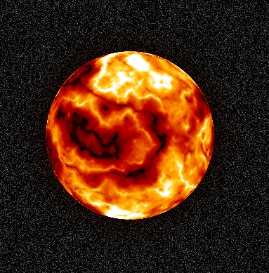](http://www.funphotoart.com/wp-content/uploads/2007/10/fireball-fire-planet-mars19.jpg)

[15] Select the shape layer go to Blending Option and select the Drop Shadow apply the following settings.

[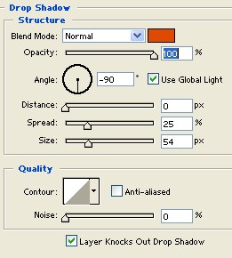](http://www.funphotoart.com/wp-content/uploads/2007/10/fireball-fire-planet-mars20.jpg)

[16] Here is your Fireball Planet.

[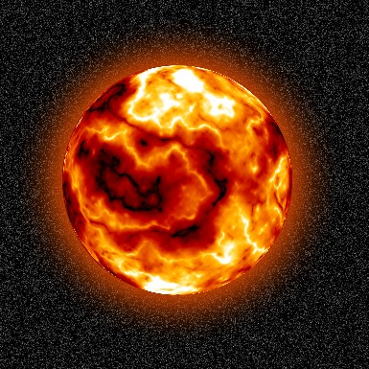](http://www.funphotoart.com/wp-content/uploads/2007/10/fireball-fire-planet-mars21.jpg)