Take a new file of 400 pixels, 400 pixels, of resolution 72 dpi in the RGB mode.

[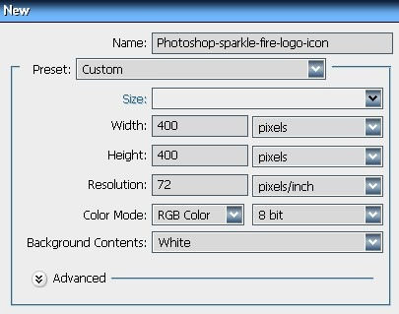](http://tutorial-zee.com/wp-content/uploads/2008/07/photoshop-sparkle-fire-logo-icon1.jpg)

[2] Take the Lasso Tool.

[Photoshop-sparkle-fire-logo-icon2](http://tutorial-zee.com/wp-content/uploads/2008/07/photoshop-sparkle-fire-logo-icon2.jpg)

[3] Make a new layer, then create a shape with the help of Lasso Tool.  
Fill the selection with White color.

[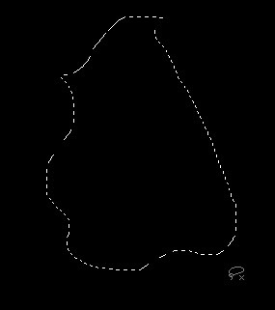](http://tutorial-zee.com/wp-content/uploads/2008/07/photoshop-sparkle-fire-logo-icon3.jpg)

[](http://tutorial-zee.com/wp-content/uploads/2008/07/photoshop-sparkle-fire-logo-icon4.jpg)

[4] After that go to Filter>Blur>Gaussian Blur apply the following settings.

[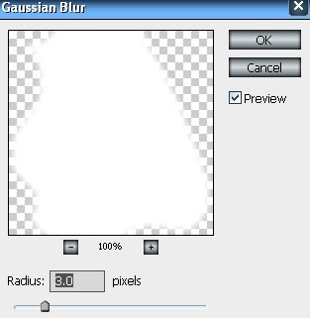](http://tutorial-zee.com/wp-content/uploads/2008/07/photoshop-sparkle-fire-logo-icon5.jpg)

[5] You get the result something like this.

[](http://tutorial-zee.com/wp-content/uploads/2008/07/photoshop-sparkle-fire-logo-icon6.jpg)

[6] Take the Smudge Tool give the properties like me.

[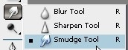](http://tutorial-zee.com/wp-content/uploads/2008/07/photoshop-sparkle-fire-logo-icon7.jpg)

[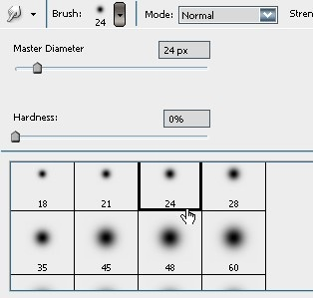](http://tutorial-zee.com/wp-content/uploads/2008/07/photoshop-sparkle-fire-logo-icon8.jpg)

[7] Using the Smudge Tool like me.

GO TO <SELECT> THEN <DESELECT>

[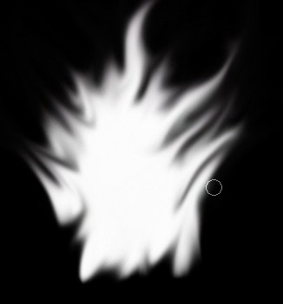](http://tutorial-zee.com/wp-content/uploads/2008/07/photoshop-sparkle-fire-logo-icon9.jpg)

[8] Go to Image>Adjustment>Color Balance.

[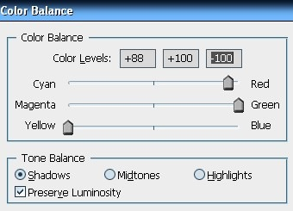](http://tutorial-zee.com/wp-content/uploads/2008/07/photoshop-sparkle-fire-logo-icon10.jpg)

[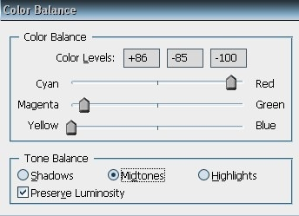](http://tutorial-zee.com/wp-content/uploads/2008/07/photoshop-sparkle-fire-logo-icon11.jpg)

[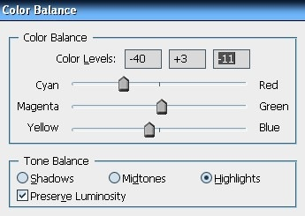](http://tutorial-zee.com/wp-content/uploads/2008/07/photoshop-sparkle-fire-logo-icon12.jpg)

[9] You get the result like this.

[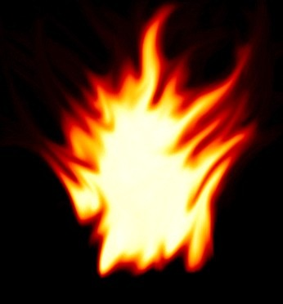](http://tutorial-zee.com/wp-content/uploads/2008/07/photoshop-sparkle-fire-logo-icon13.jpg)

[10] This is my final result.

[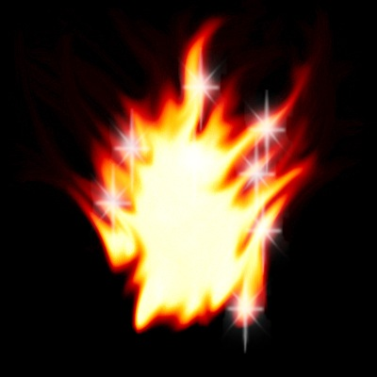](http://tutorial-zee.com/wp-content/uploads/2008/07/photoshop-sparkle-fire-logo-icon14.jpg)