1. Copy image of the city from the website and open it up in photoshop.
2. Select the brush brush tool.
3. Click on the window button at the top of the screen and click brushes.
4. Click on “brush tip shape” and make the settings like this picture. **[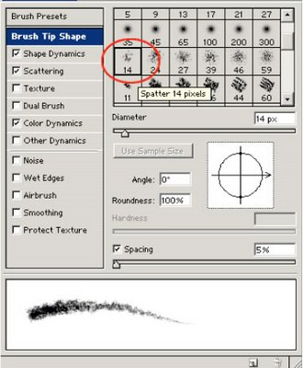](http://bp2.blogger.com/_rYaVWow4Vz0/SEUxMCnjOOI/AAAAAAAABAY/6D3hOrZ4R4c/s1600-h/3.jpg)**
5. Click on “shape dynamics” and make your settings similar to the picture shown here. **[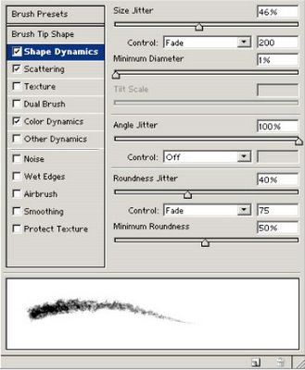](http://bp2.blogger.com/_rYaVWow4Vz0/SEUxaCnjOPI/AAAAAAAABAg/kpIXjfFwygI/s1600-h/4.jpg)**
6. **Now do the same for “scattering”**

[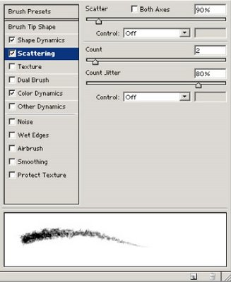](http://bp3.blogger.com/_rYaVWow4Vz0/SEUxkSnjOQI/AAAAAAAABAo/b--UeP2UU-I/s1600-h/5.jpg)

1. Finally do “color dynamics”.

**[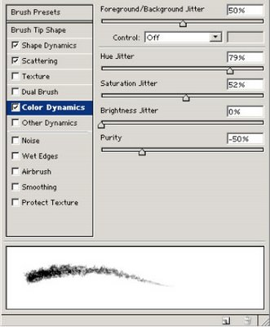](http://bp2.blogger.com/_rYaVWow4Vz0/SEUxuCnjORI/AAAAAAAABAw/hTt_DXU6UTQ/s1600-h/6.jpg)**

1. Next we need to change the foreground and background colors. (the black and white boxes at the bottom left part of screen) For the foreground put in bright red(R.255) (B.0) and (G.0). Make the background color to bright orange (R.255) (G.155) (B.0). Doing this will vary how your brush strokes will look later on.
2. Add a new layer.
3. Start painting your fireworks on the city background. (Make sure you move draw from the outside inward) The brush stokes/fireworks are pretty big, but leave them alone for now. You want to draw the fireworks in a circular motion to replicate a firework explosion. Like this.

**[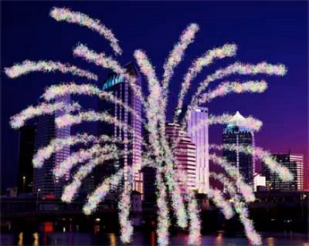](http://bp2.blogger.com/_rYaVWow4Vz0/SEUyFCnjOTI/AAAAAAAABBA/bVNl1KXw6Y8/s1600-h/8.jpg)**

1. We’re going to scale down the firework by pressing ctrl+T. Hold down the shift button while scaling down to shrink the firework equally. It should look similar to this.

**[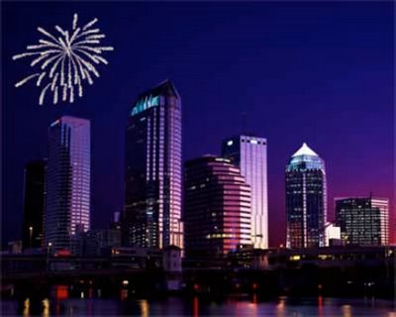](http://bp3.blogger.com/_rYaVWow4Vz0/SEUyfSnjOUI/AAAAAAAABBI/S0FU4Z1RuTw/s1600-h/9.jpg)**

1. Put a mask on the fireworks layer so it looks like this.

**[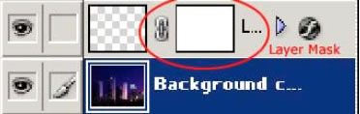](http://bp3.blogger.com/_rYaVWow4Vz0/SEUy2SnjOVI/AAAAAAAABBQ/HunAhmQKnZY/s1600-h/10.jpg)**

1. Click on the mask layer. Select the gradient tool (the box under the eraser tool). Once you have done that click on radial gradient at the top of screen. After doing this find the center of your firework explosion and from the middle of it go outwards about 1/4th the length of the explosion. This gives the effect of the explosion fading from the middle of the explosion getting brighter on the outer edges.
2. If you have followed the instructions your picture should look like this.

**[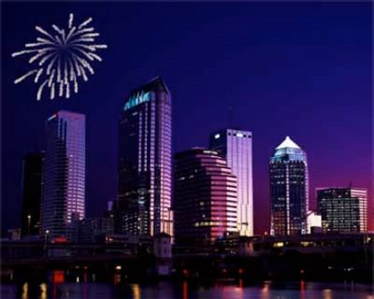](http://bp3.blogger.com/_rYaVWow4Vz0/SEUzVSnjOYI/AAAAAAAABBo/J08jFybK4jk/s1600-h/13.jpg)**

1. Double click on the fireworks layer to bring up the layer styles. Click on the outer glow box to make some changes. Make the changes to match this picture.

**[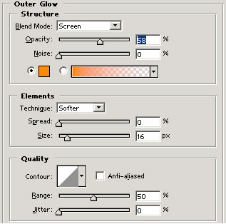](http://bp2.blogger.com/_rYaVWow4Vz0/SEUzhCnjOZI/AAAAAAAABBw/qcvBNF6l3MA/s1600-h/14.jpg)**

1. To make more fireworks you can repeat the steps above again or copy the layer you’re on and free transform it. Copy the fireworks layer by pressing (ctrl+J), then press (ctrl+T). (Make sure you are on the new layer you have created!) Drag the copy of the firework to another part of the screen and rotate it a little bit so it isn’t noticeable that it’s a copy.
2. To make the copied firework a new color click twice on the copy layer. Click on “outer glow” and mess with the color settings.
3. Compare your picture with mine, you’re done!

