Vincent Jaramillo

Graphic design

10/07/08

Step 1: Firstly, you have to look for a nice background. You can use this background [here](http://www.sxc.hu/browse.phtml?f=download&id=968171) or use the image below, which is in a lower resolution:

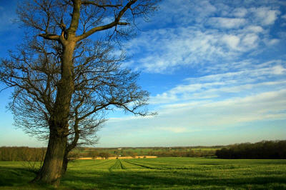

Open it in Photoshop. If you download the original image then you should resize it to 800x533 pixels by going to **Image > Image Size** and set a width of **800 pixels**, the height will be auto resized accordingly.

Step 2: Create a new layer (Ctrl-Shift-N) and use the **Elliptical Marquee Tool** (M) to select a circular area

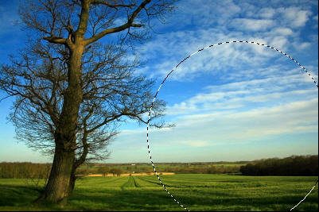

Step 3: Press **D** and **X** to reset your foreground and background colors. Press **Ctrl-Backspace** to fill the circular selection with black

Go to **Filter > Render > Clouds** to fill it with clouds. Go to **Filter > Render > Difference Clouds** to put your clouds in contrast. Press **Ctrl-F** to repeat this effect again

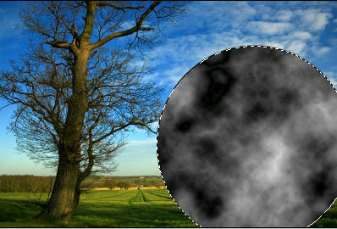

Step 4: Press **Ctrl-D** to deselect it. Press **Ctrl-U** to open up the **Hue/Saturation** dialog box. Make sure to tick on the **Colorize** checkbox and use these settings:

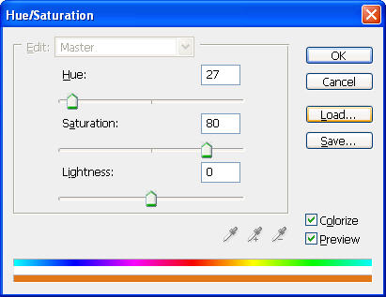

Now our circle turn out into an orange planet but we have to make it more real

Step 5: Double click on **Layer 1**, which contains our planet and use these effects

    + **Drop Shadow**:

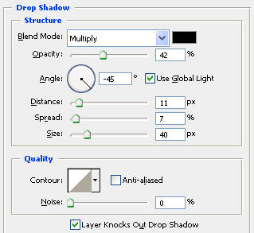

    + **Inner Shadow**:

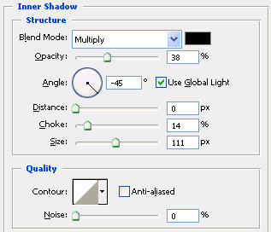

    + **Outer Glow**:

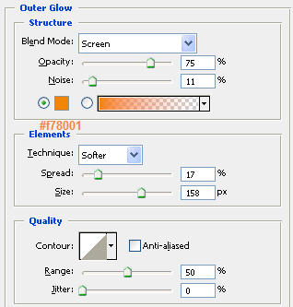

    + **Inner Glow**:

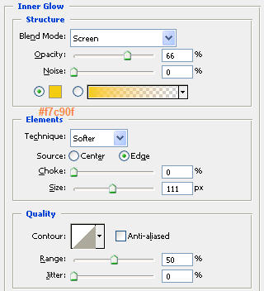

Now our image will look like this:

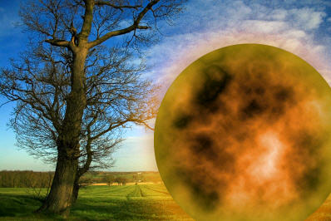

Step 6: Use the **Erase Tool** (E) to erase the bottom of our image so that our audience believes it lying at the horizon

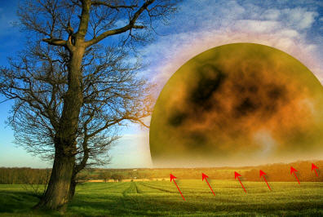

Step 7: Our planet does not look impressive now, it needs more contrast so go to **Image > Adjustments >Levels** and use these settings:

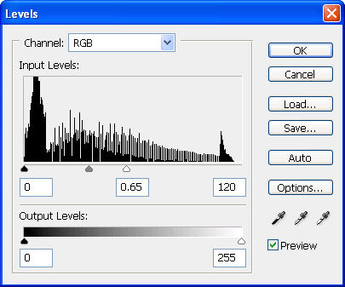

Now it looks really impressive, doesn't it?

Step 8: And finally, we need some lighting effects to make our image brighter. Click on  your background in the **Layers** tab to set it as the current layer. Go to **Filter > Render > Lighting Effects** and use these settings:

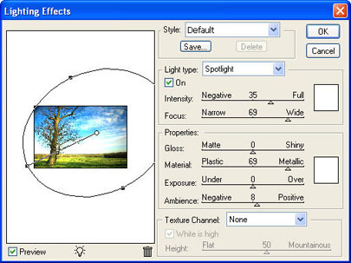

Finished! Here is the final result:

