**Sand Stone Apple Effect**

1. ***Download the apple picture from the website***

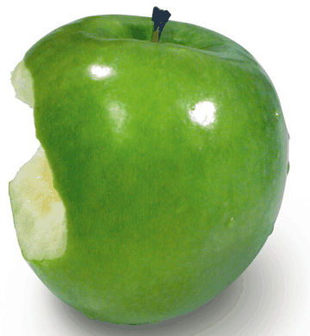

1. ***Open the picture using file open or Ctrl-O***
2. ***Select the picture, copy and paste in on the new canvas.***
3. ***Cut out the apple or the background from picture***
4. ***Go to file new and open a new canvas to be 360 by 390 pixels***
5. ***Using Ctrl-J duplicate the first layer***
6. ***On the duplicated layer using Ctrl-U; this should open Hue/Saturations box***
7. ***In the Hue type +113, on Saturated type +67 and on Lightness type +10, press okay***

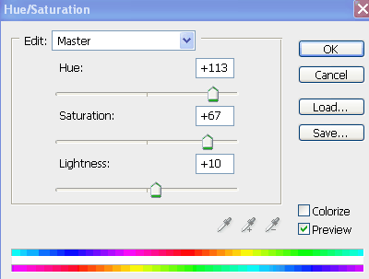

1. ***Duplicate the first layer again(this layer should be the first) the blending mode should be Overlay***
2. ***The original picture should not show any eye or layer visibility. (TURN IT OFF)*** 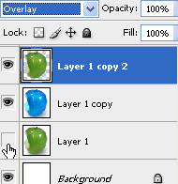
3. ***Duplicate the original image again(THIS LAYER SHOULD SAY LAYER 1 COPY 3)***
4. ***Leave this layer alone for now….you will need it later***
5. ***On layer 1 copy 2 go to filter>texture>craquelure***

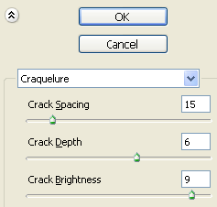

1. ***Once your done with the craquelure, make copy 3 below copy 2(copy 2 should be overlay)***
2. ***Your finished product should look like this***

[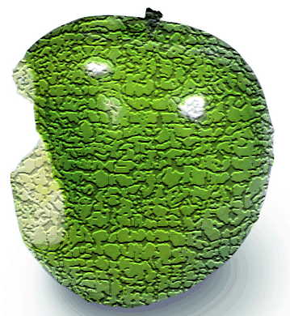](http://tutorialqueen.com/wp-content/uploads/2008/06/photoshop-sand-stone-apple-effect7.gif)

1. ***Copy the apple into the second image and save it into your folder (frausto_applestoneeffect)***