Explosion Effect

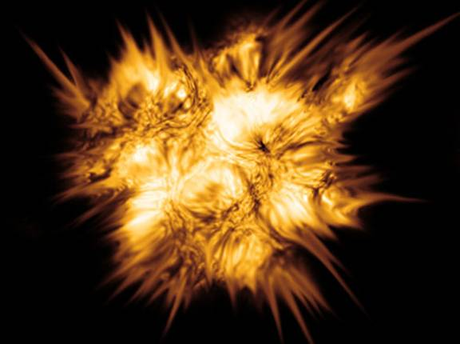

Step 1: First open a new file, 680x510 pixels and then press D to set colors to black and white

Step 2: Go to Filters>Render>Clouds

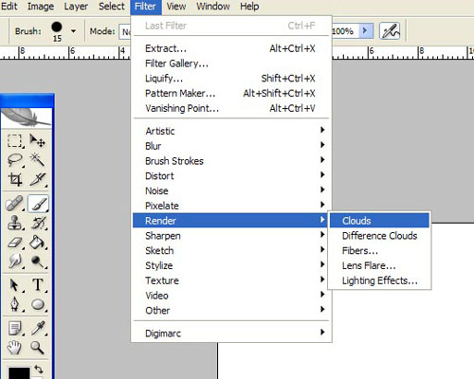

Step 3: Go to Filters>Stylize>Find Edges

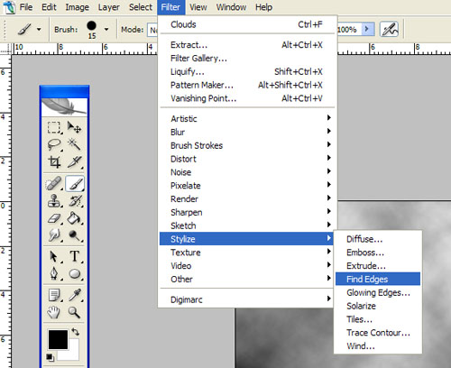

Step 4: Press Ctrl+L to open levels window and then select Auto

Step 5: Click on your brush tool. On the top left hand corner click on the arrow and click on the airbrush. Make a cloud shape.

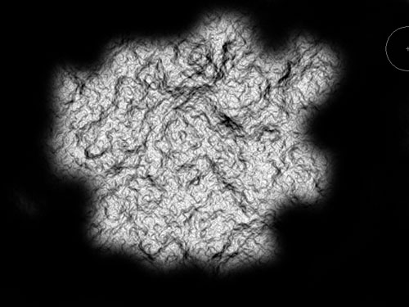

Step 6: Click on your Magic Wand Tool and select the black part

Step 7: Right Click and go to Select Inverse

Step 8: Press Shift+Ctrl+X to open the class=SpellE>Liquify window.

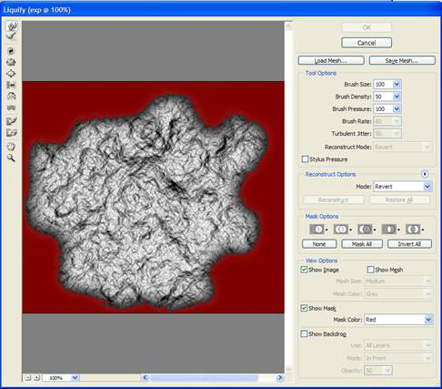

Step 9: Use the Plucker and Bload Tool to make some bubbles and concave click on OK

http://tu-torial.com/images/photoshop/effects/explosion_effect/image010.jpg

Result:

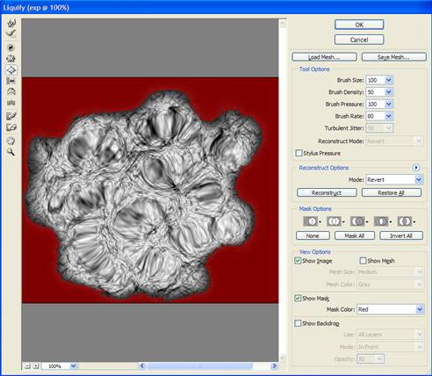

Step 10: Press Ctrl+D to deselect

Step 11: Go to Image>Adjustments>Gradient Map

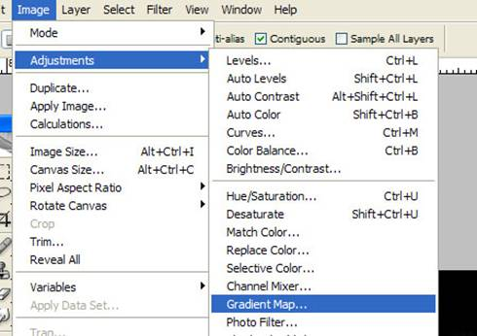

Step 12: Click on the color bar to change the colors to Black>Brown>Yellow>White

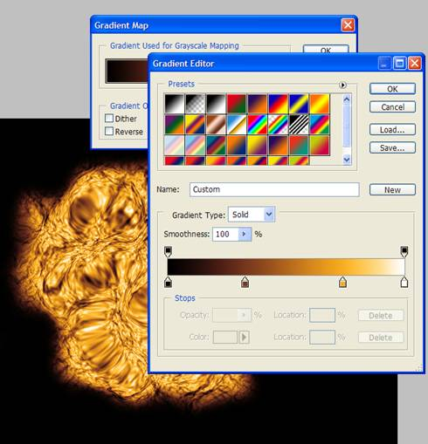

Step 13: Click on your Dodge Tool to make some areas of the explosion brighter. http://tu-torial.com/images/photoshop/effects/explosion_effect/image016.jpg

Step 14: Click on your Burn Tool to make some areas of the explosion darker.

Step 15: Now use your Smudge Tool to smudge the outside area of the explosion and use the Blur Tool to blur it.

