Fire Wheels

**Step 1**- get car form MR. B’s web site. Then Press D and X to reset Background and foreground effects.

**Step 2**: Create a new layer and press **Ctrl-Backspace** to fill it with black. You should reduce the opacity of this layer to **70%** so we can see our car

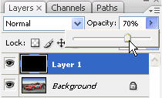

**Step 3**: Go to **Filter > Render > Lens Flare** and try to put this flare on the center of our front wheel

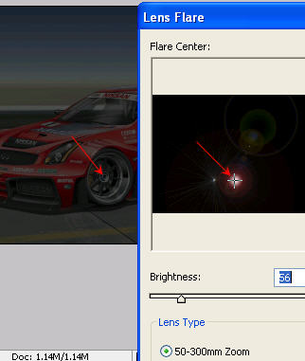

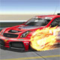This tutorial will show you how to make real fire that together with good photography can be used to make impressive results

Here is the effect we will make in this tutorial

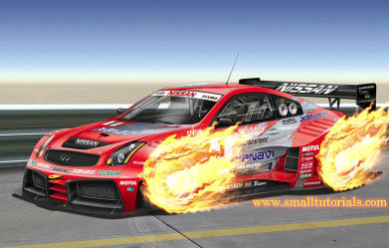

**Step 1**: We need a car for this tutorial so you can get one from the Internet or use the picture below

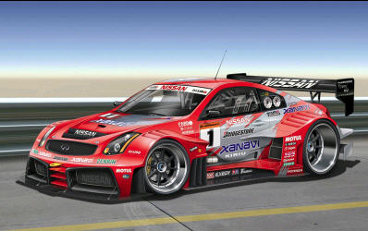

Open this picture in Photoshop, press **D** and **X** to reset your background and foreground colors

**Step 2**: Create a new layer and press **Ctrl-Backspace** to fill it with black. You should reduce the opacity of this layer to **70%** so we can see our car



**Step 3**: Go to **Filter > Render > Lens Flare** and try to put this flare on the center of our front wheel



**Step 4**: Use the **Elliptical Marquee Tool** (maybe you have to right click on the Marquee Tool and select Elliptical Marquee Tool option) to draw an ellipse. Be sure to make it bigger than our wheel and the lens flare must lie inside it

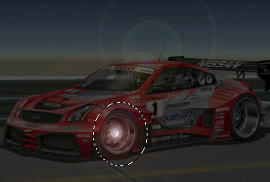

**Step 5**: Go to **Filter > Artistic > Plastic Wrap** and use these settings

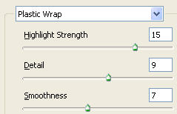

**Step 6**: Expand the selection by going to **Select > Modify > Expand** and use a value of **30 pixels**. We have to do it because we need more space for the next effect

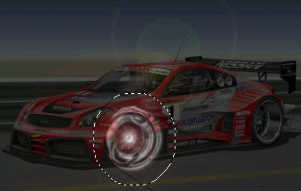

**Step 7**: Now go to **Filter > Distort > Twirl** and set a big angle:

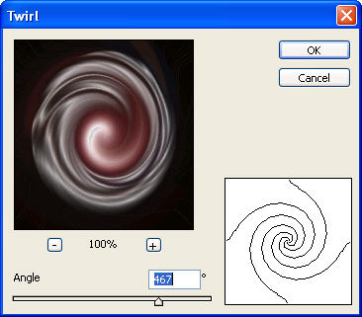

**Step 8**: Press **Ctrl-D** to deselect. Go to **Filter > Stylize > Wind** and use these settings

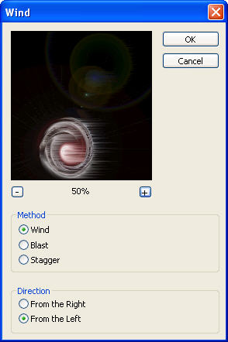

Press **Ctrl-F** twice to make this effect stronger

**Step 9**: Now this is the most important step. We will make the fire by going to **Filter > Liquify**. Use an average brush size (about 19 pixels) with the **Forward Warp Tool** to play with your image. Here is my suggestion ^_^ (please remember we are in the Liquify dialog box)

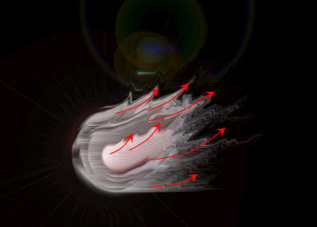

**Step 10**: Change the opacity of your "fire" layer (Layer 1 by default) to **100%** again

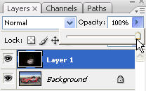

**Step 11**: Press **Ctrl-B** to open up the **Color Balance** dialog box, we just need to adjust its hightlights, so click on the **Highlights** option and use these settings

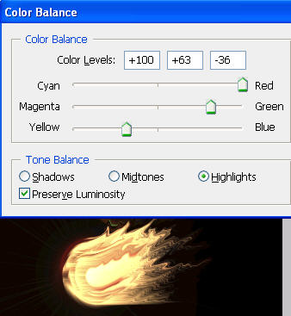

Step 12: Change the Blending Mode of Layer 1 to **Screen** to eliminate black areas

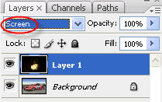

Step 13: Go to **Edit > Transform > Warp** and move the right-bottom point upward (red arrow). We can see the bottom of our fire move up a little (green arrow)

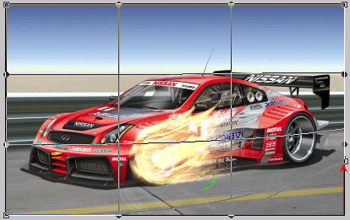

**Step 14**: We need to adjust the color of our fire so go to **Image > Adjustments > Levels** (or press Ctrl-L) and use these settings

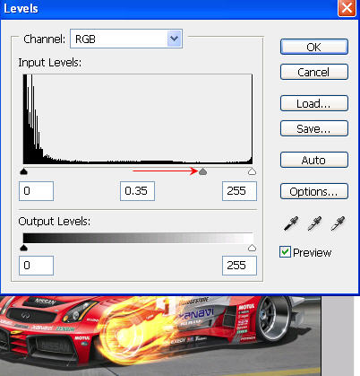

**Step 15**: We are going to finish! Go to **Filter > Distort > Ripple** and use a value around 115%

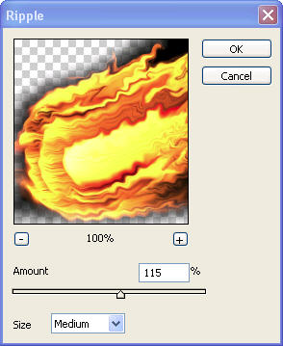

And ...finish! This is the final result

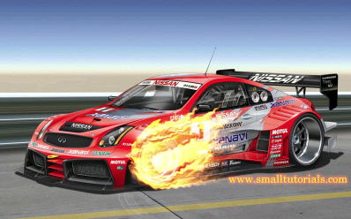

**Step 16: do the back wheel now!**