The Raindrop Ripple

1. Create a new canvas with dimensions of 1024 x 724 pixels. Fill this in with black. (D, then ALT-BACKSPACE) Create another layer (CTRL-ALT-SHIFT-N) and make it black as well.
2. On the top layer, select FILTER>RENDER>LENS FLARE. Brightness at 100% and 50-300mm zoom selected. Repeat to make it brighter. (CTRL-F)
3. Select FILTER>DISTORT>TWIRL and increase the twirl to 999. Repeat this to make the right kind of twirl.

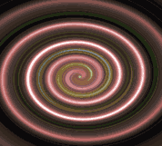

1. Now select EDIT>TRANSFORM>DISTORT and adjust by pulling down one of the corners to make it look like a flat surface.

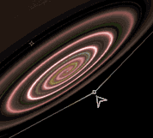

1. Now select EDIT>FREE TRANSFORM and then rotate it to make it level.
2. Select LAYER>FLATTEN IMAGE.
3. Right click on the background layer in the box and create a copy. (duplicate layer)
4. Select the bottom layer (should be background) and select FILTER>BLUR>GAUSSIAN BLUR and make the blur radius 3.5 pixels.
5. Set the top layer to multiply. (This is the pull-down menu just above the layers on the canvas.)
6. Select LAYER>FLATTEN IMAGE.
7. Select the burn tool (This is the tool in the menu under the little drop symbol. The tool menu it’s in looks like a lollypop.) And have the range be midtones, exposure should be 20%. Use this to burn out the green part from the lens flare in the center. This will take a little time.
8. Select the dodge tool (the lollypop) and the range this time should be highlights and exposure should be 30%.

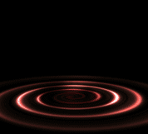

1. Create a new layer. (Not a copy.)
2. The layer style should be color. (the drop-down menu above the layers shown)
3. Select the gradient tool and select either radial or diamond gradient.
4. The color is your choice. You can make your own by clicking the colors (not the arrow) and choosing the ones you like. I recommend colors visible against black.
5. Click and drag to make the effect as you wish.
6. Create one more new layer.
7. Select the brush tool and change to one of the colors on the ripple.
8. You can either reduce to one pixel and click like crazy, or pull down the brush menu at the top and select a scatter brush. I recommend the ones at the bottom of the list. They should look like a bunch of random dots. (OBVIOUS!!!)
9. Good job, you have made a good ripple on a black lake!

