1] Take a new file of 300 pixels, 300 pixels, of resolution 72 dpi in the RGB mode.

[2] Take the Text Tool create your text the color is #184c73.

[](http://tutorial-zee.com/wp-content/uploads/2008/06/photoshop-design-electric-text-effect1.jpg)

[3] Add the following layer styles.

[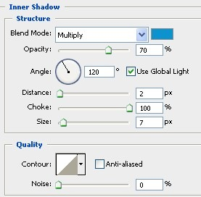](http://tutorial-zee.com/wp-content/uploads/2008/06/photoshop-design-electric-text-effect2.jpg)

[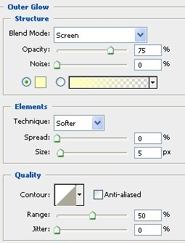](http://tutorial-zee.com/wp-content/uploads/2008/06/photoshop-design-electric-text-effect3.jpg)

[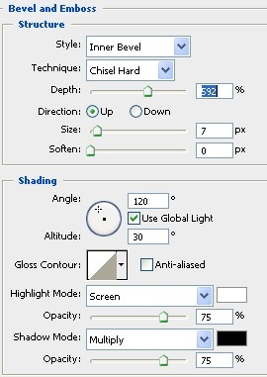](http://tutorial-zee.com/wp-content/uploads/2008/06/photoshop-design-electric-text-effect4.jpg)

[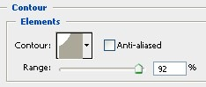](http://tutorial-zee.com/wp-content/uploads/2008/06/photoshop-design-electric-text-effect5.jpg)

[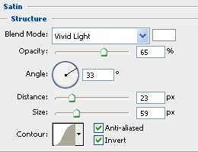](http://tutorial-zee.com/wp-content/uploads/2008/06/photoshop-design-electric-text-effect6.jpg)

[](http://tutorial-zee.com/wp-content/uploads/2008/06/photoshop-design-electric-text-effect7.jpg)

[4] Create a new layer, fill it with white, and set foreground color to black (#000000). Go to Filter > Texture > Stained Glass, use the following settings and click OK

[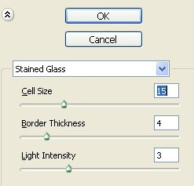](http://tutorial-zee.com/wp-content/uploads/2008/06/photoshop-design-electric-text-effect8.jpg)

[5] Use the Magic Wand Tool to select the black part.

[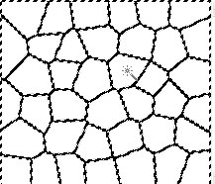](http://tutorial-zee.com/wp-content/uploads/2008/06/photoshop-design-electric-text-effect9.jpg)

[6] Set the foreground color.

[Photoshop-design-electric text-effect10](http://tutorial-zee.com/wp-content/uploads/2008/06/photoshop-design-electric-text-effect10.jpg)

[7] Create a new layer and fill the selected area. Delete or hide the old/previous layer underneath.

[](http://tutorial-zee.com/wp-content/uploads/2008/06/photoshop-design-electric-text-effect11.jpg)

[8] CTRL + Click on the text layer. Go to Select > Modify > Expand. Set it to 4 and click OK.Right Click on the selection and click Select Inverse. With the top layer selected, go to Edit > Clear.

[](http://tutorial-zee.com/wp-content/uploads/2008/06/photoshop-design-electric-text-effect12.jpg)

[](http://tutorial-zee.com/wp-content/uploads/2008/06/photoshop-design-electric-text-effect13.jpg)

[](http://tutorial-zee.com/wp-content/uploads/2008/06/photoshop-design-electric-text-effect14.jpg)

[9] Go to Filter > Distort > Ripple, set the Amount to 100% and the size to Medium, click OK.

[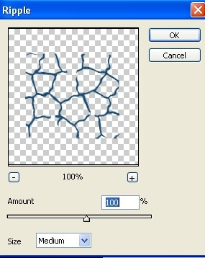](http://tutorial-zee.com/wp-content/uploads/2008/06/photoshop-design-electric-text-effect15.jpg)

[10] Apply the following blending options to this layer.

[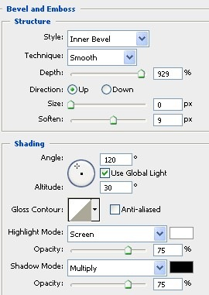](http://tutorial-zee.com/wp-content/uploads/2008/06/photoshop-design-electric-text-effect16.jpg)

[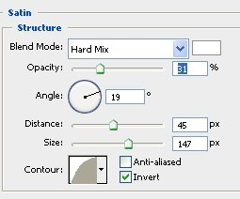](http://tutorial-zee.com/wp-content/uploads/2008/06/photoshop-design-electric-text-effect17.jpg)

[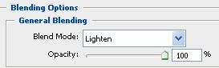](http://tutorial-zee.com/wp-content/uploads/2008/06/photoshop-design-electric-text-effect18.jpg)

[11] This is my final result.

[](http://tutorial-zee.com/wp-content/uploads/2008/06/photoshop-design-electric-text-effect19.jpg)