**Jensen Speed Text Tutorial**

**Step One:** Open a new document, make it 900 by 500 pixels, make the background black and type your letters in white, make the font size 150. Now press Ctrl+E to reduce the layers to the background.

**[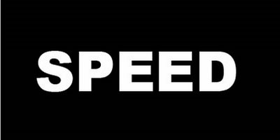](http://bp3.blogger.com/_rYaVWow4Vz0/SE-cYsK8IhI/AAAAAAAABE4/SdAX2CxzVNA/s1600-h/1.jpg)**

**Step Two:** Now go filters => Blur => Gaussian Blur and set it at 1.5.

**[](http://bp0.blogger.com/_rYaVWow4Vz0/SE-clhNZ4FI/AAAAAAAABFA/RvvLwTYE3qo/s1600-h/2.jpg)**

**Step Three:** Next we need Filters => Stylize => Solarize. Your text should look like this.

**[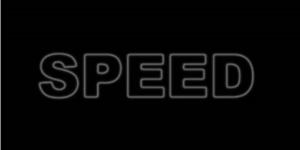](http://bp0.blogger.com/_rYaVWow4Vz0/SE-ctsit4oI/AAAAAAAABFI/rplhfMBZiS4/s1600-h/3.jpg)**

**Step Four:** Then use image => Adjustment => Channel Mixer and set the values like below.

**[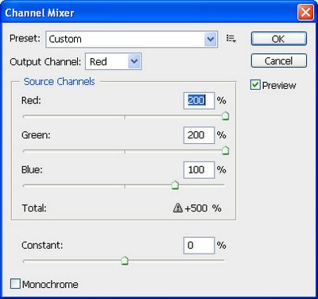](http://bp1.blogger.com/_rYaVWow4Vz0/SE-c2ioS0oI/AAAAAAAABFQ/hBuODOCKgLU/s1600-h/4.jpg)**

Then your text should look like this.

**[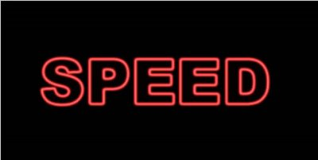](http://bp2.blogger.com/_rYaVWow4Vz0/SE-c-DSVExI/AAAAAAAABFY/t9idX04XghQ/s1600-h/5.jpg)**

**Step Five:** Now go Filters => Distort => Polar Coordinates and choose the lower -Polar to Rectangular- radio button.

**[](http://bp2.blogger.com/_rYaVWow4Vz0/SE-dF9NyUdI/AAAAAAAABFg/hMvOoZOxCrg/s1600-h/6.jpg)**

**Step Six:** Now go to Image => Rotate Canvas => 90°CCW.

**Step Seven:** Apply Filters => Stylize => Wind - from left – Do this two times.

**[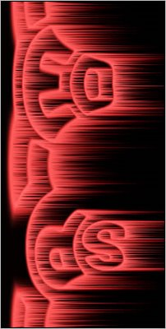](http://bp3.blogger.com/_rYaVWow4Vz0/SE-dOnkIuOI/AAAAAAAABFo/nazFaxjkuqw/s1600-h/7.jpg)**

**Step Eight:** Then go to image-rotate canvas 90°CW. Now go again Filters => Distort => Polar Coordinates and this time choose the upper -Rectangular to Polar- radio button. And you have the speed text effect!

**[](http://bp1.blogger.com/_rYaVWow4Vz0/SE-dWQPjbLI/AAAAAAAABFw/qhw2spD-41A/s1600-h/8.jpg)**