1. First copy this picture form the website. and open it so that it is your background.

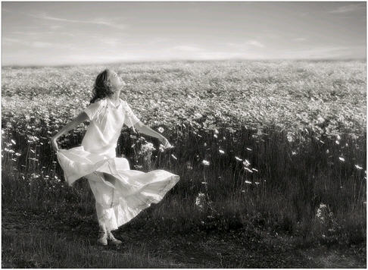

1. Now we are going to add some color to our photo go to **Image > Adjustments > Color Balance adjust only the midtones**

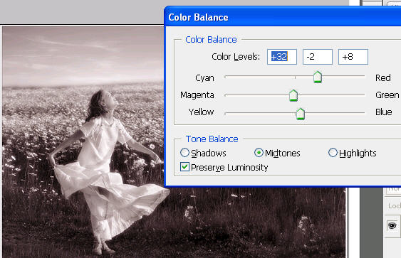

1. Reset your foreground and background colors by pressing D.
2. Create a new layer
3. Go to **Filter > Render > Clouds to create to create some clouds over your photo**

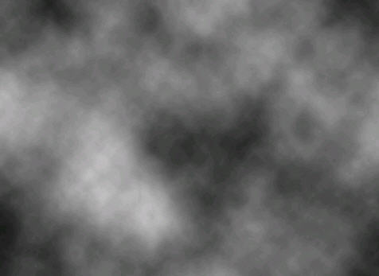

1. Go to **Filter > Render > Difference Clouds and repeat three or four times to get your picture like this.**

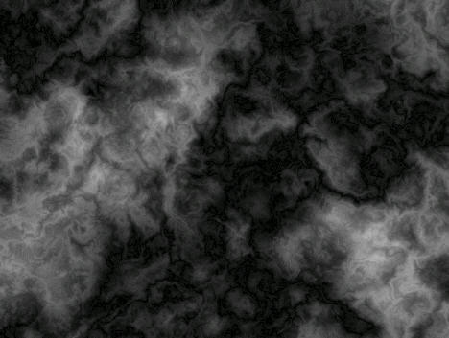

1. Go to **Image > Adjustments > Brightness / Contrast and use the following settings.** 
   1. **Brightness: 150**
   2. **Contrast: 100**

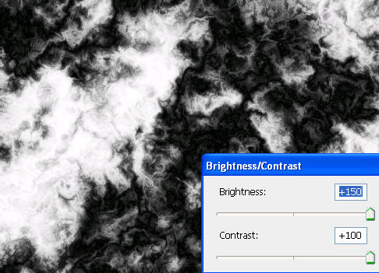

1. Now increase the black with areas by going to **Image > Adjustments > Levels and move the black and white tabs in towards the middle.**

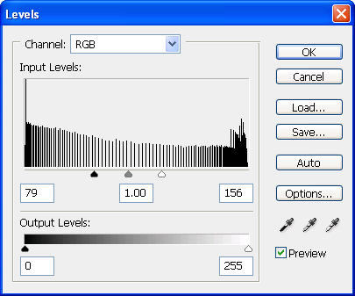

1. **Go to Filter > Blur > Motion Blur and use these settings**
   1. **Angle: 42**
   2. **Distance: 999**

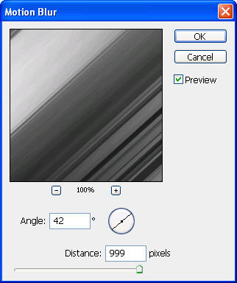

1. Change the blending mode of this layer to soft light.
2. The light might still be too sharp. Go to **Filter > Blur > Gaussian Blur and adjust the settings to make the light blur to desired effect.**

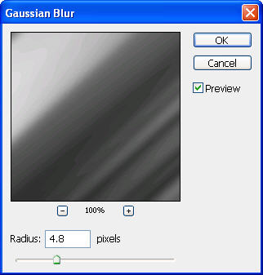

1. Now add a mask on your layer.
2. Select the gradient tool on the left side of the screen
3. Select a white to black radial gradient options.

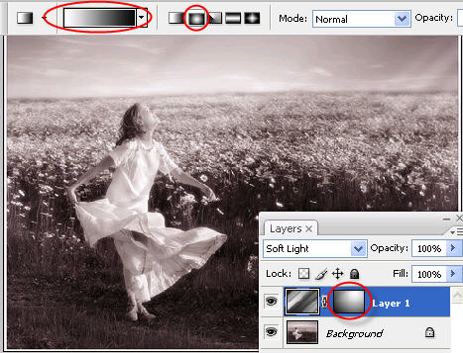

1. Press Ctrl-J to copy the layer
2. Now to bring a little color to our light create a new layer. And select the brush tool with a soft brush and an orange foreground.
3. Paint your photo like so.

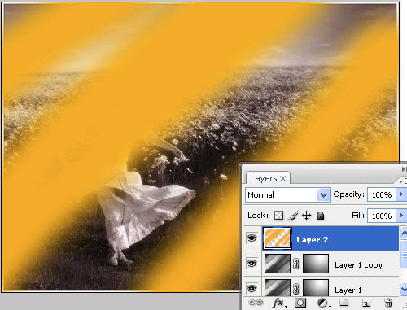

1. Now change the blending mode to soft light.