Reflective Eye

Amada Gonzalez

Copy these 2 pictures from Mr. Burkhard’s website

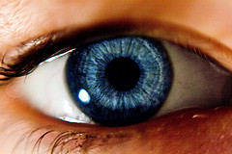 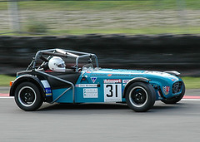

Create a new document on Photo shop 500 x 500

Open the eye and the car in this document. Select the layer with the car and driver. Slightly distort the layer for perspective. **Edit >> Transform >> Perspective**

Scale this layer so that it is slightly bigger than the eye.

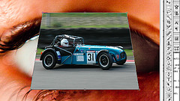

Create a new layer. On this layer you will fill the sphere selection with a solid color.

Click on the car layer now you will spherize (**Filter >> Distort >> Spherize**)

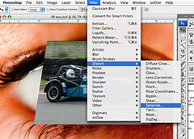

Use a setting of 75 %

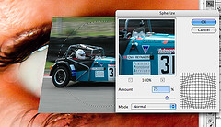

Now add a layer mask to the car layer. Make sure to draw away any part that is not in the sphere that you made earlier. Use a brush with a hardness of 0% so you can draw natural fades for the reflected area.

Next change the **Blend Option on** your reflection layer to “**Hard Light**” Reduce the opacity to 80%.

