***Sound Equalizer Tutorial***

1. First, create a black background
2. Create a strip of a color on a new layer. 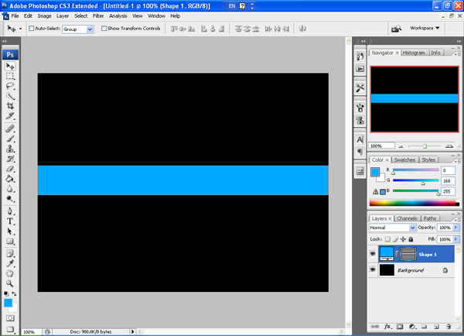
3. Rotate the canvas clockwise 90 degrees
4. In the menu, go to (Filter -> Stylize -> Wind) 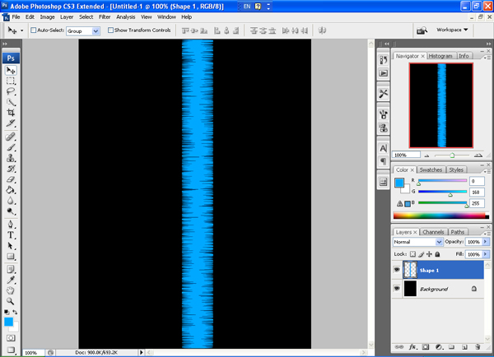
5. Do this to both sides a couple times.
6. Merge the background with the layer that has your stripe on it.
7. Repeat (Filter -> Stylize -> Wind) to your layer at least twice in each direction. 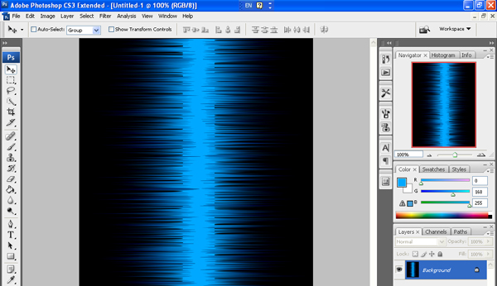
8. To add it some glow, go to (Image -> Adjustments -> Brightness/Contrast) and adjust both contrast and brightness. 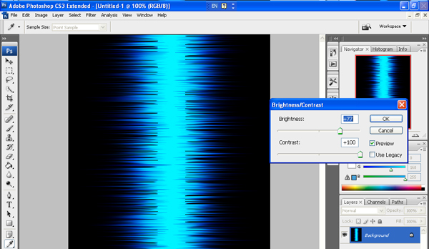
9. You can use the Dodge and Burn Tool to spice up the image.
10. Rotate the image counter clock wise 90 degrees, and you’re done! 