Technology 1

AutoCAD Daily Assignment ONE, Line Command

BEFORE YOU START: Create a new folder in your AUTOCAD folder, called “lastname_AUTOCAD_1”. Save the following figures into this folder, call them drawing1.dwg, drawing2.dwg, etc.

FIGURE 1- Use the LINE command to draw the following graphic design using absolute coordinates:
- LINE>Enter
- 1.5,5.75
- 3.25,5.75
- 3.25,4.5
- 5,6.375
- 3.25,8.25
- 3.25,7
- 1.5,7
- 2.125,6.375
- 1.5,5.75
- Hit Enter or ESC to Cancel the Line Command
- Save drawing to your “lastname_AUTOCAD_1” folder as drawing1.dwg

FIGURE 2- Use the LINE command to draw the following figure using absolute coordinates:
- 2,2
- 4,2
- 4,3.5
- 3,3.5
- 3,4
- 2,4
- 2,2
- ENTER or ESC to Cancel the Line Command
- LINE>Enter
- 2,2.75
- 4,2.75
- ENTER or ESC to Cancel the Line Command
- LINE>Enter
- 3,2
- 3,2.75
- ENTER or ESC to Cancel the Line Command
- Save drawing to your folder as drawing2.dwg

FIGURE 3- Use the LINE command to draw the sheet metal part using the following relative coordinates after the initial absolute coordinates:
- LINE>Enter
- 2, 2 (absolute coordinates)
- @3.25,0 (relative coordinates)
- @0,1.875
- @-.875,0
- @0,.75
- @1.75,0
- @0,3.125
- @-.5,.5
- @-1.5,0
- @-.75,-.75
- @-.75,.75
- @-.25,0
- @0,-2
- @.25,0
- @0,-3.5
- @-.25,-.25
- @-.375,0
- Press C for Close
- Save the drawing to your folder as drawing3.dwg

FIGURE 4- Use the Line Command to draw the following figure using relative coordinates:

- LINE>Enter
- 6,2 (absolute coordinates)
- @2,0 (relative coordinates)
- @0,2
- @-.75,0
- @0,-1.25
- @-1.25,0
- @0,-.75
- ENTER or ESC to Cancel Line Command.
- Save Drawing to your folder as drawing4.dwg

FIGURE 5- Use the LINE command to draw the latch plate using the following polar coordinates after the initial absolute coordinate:
- LINE> Enter
- 3,4 (absolute coordinates)
- @.5<0 (polar coordinates)
- @.625<90
- @2.5<0
- @2.375<90
- @.75<180
- @1.5<270
- @2.25<180
- @.75<225
- @.375<270
- Press C for Close
- Save the drawing to your folder as drawing5.dwg

FIGURE 6- Use the LINE command to draw the trophy base using the following polar coordinates:
- LINE>Enter
- 3,4 (absolute coordinates)
- @2<45 (polar coordinates)
- @2<315
- @1.5<270
- @2.8284<180
- @1.5<90
- ENTER or ESC to cancel the Line Command
- Save the drawing to your folder as drawing6.dwg

FIGURE 7- Use the LINE command to draw the trophy base using the following combination of coordinates:
- 1.5,3 (absolute coordinates)
- @5,0 (relative coordinates)
- @1<90 (polar coordinates)
- @5<180 (polar coordinates)
- Press C for Close
- Press Enter or Space Bar
- 2.25,4 (absolute coordinates)
- @4.5<90 (polar coordinates)
- @1.75, 1.75 (relative coordinates)
- @1.75,-1.75 (relative coordinates)
- @4.5<270 (polar coordinates)
- Cancel
- Press Enter or Space Bar
- 2.75,4.75 (absolute coordinates)
- @2.5,0 (relative coordinates)
- @3.5<90 (polar coordinates)
- @2.5<180 (polar coordinates)
- Press C for Close
- Save the drawing to your folder as drawing7.dwg

FIGURE 8- Use the LINE command to draw the picture frame using the following combination of coordinates:
- Point 1: 1,1 (absolute coordinates)
- Point 2: @6.5,0 (relative coordinates)
- Point 3: @9<90 (polar coordinates)
- Point 4: @-6.5,0 (relative coordinates)
- Press C for Close
- Press Enter or Space Bar
- Point 5: 1.5,1.5 (absolute)
- Point 6: @5.5,0 (relative)
- Point 7: @8<90 (polar)
- Point 8: @5.5<180 (polar)
- Press C for Close
- Make sure that the Gray OBJ SNAP Button at the bottom of the screen is turned ON
- Press Enter or Space Bar
  - Click Point 1 (Points as defined in the problem above)
  - Click Point 5
  - Cancel
- Press Enter or Space Bar
  - Click Point 2
  - Click Point 6
  - Cancel
- Press Enter or Space Bar
  - Click Point 3
  - Click Point 7
  - Cancel
- Press Enter or Space Bar
  - Click Point 4
  - Click Point 8
  - Cancel
- Save the drawing to your folder as drawing8.dwg

FIGURE 9- Using MICROSOFT WORD, create a listing of all of the steps required to create the following figure (like the problems above have done). (NOTE that the figure STARTS at point 2,2). Please use all methods of Line Creation in this exercise: Polar, Relative and Absolute.

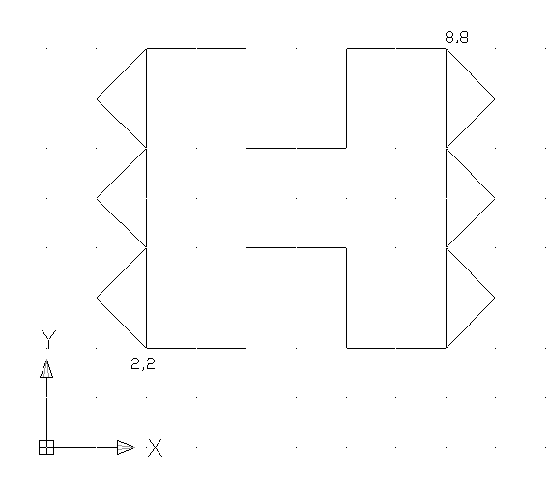
Save the figure to your folder as Drawing 9.

Problems 10-14: From the RED BOOK, replicate the following figures, USING ANY VERSIONS OF THE LINE COMMAND THAT YOU WISH, INCLUDING DIRECT DISTANCE:
- PAGE 31, Problems 1-2
- PAGE 32, Problems 3-4.
Save these problems to your “lastname_AUTOCAD_1” folder as drawing10.dwg, drawing11.dwg, etc.

CHALLENGE PROBLEMS:

If you have completed AutoCAD Assignment 1 and would like an additional challenge, go to the RED BOOK, page 78 and complete the problems exactly as described in the book.

Make sure that you use all three of the line input methods that we have discussed so far, Absolute, Relative and Polar Coordinates in your listing.

SUBMITTING YOUR WORK: When you have completed all 13 problems, copy your entire “lastname_AUTOCAD_1” folder to the M: Drive Drop Box for your class period.

GRADING: I might grade one of these problems. I might not. Don’t know yet. I WILL be giving a large participation grade based upon whether or not you are working on these problems.

